Annual impact analysis report
SEND Schools’ Workforce Contract 2021-22 WHOLE School SEND

Annual Impact Analysis Report
Contents
List of figures 3
List of tables 3
Foreword 5
Whole School SEND values 7
Executive summary 8
Key Findings 8
Engagement with the member community 8
Quality outcomes and impact 8
What we have learnt from the evidence 10
Introduction 12
Objectives of contract 12
Aims of the evaluation activity / strategy 12
Methodology 13
Consideration of the limitations of the evaluation 13
Strand 1a Regional CPD 14
Intent: Aims of the strand 14
Implementation: Summary of activity within strand 14
Evaluation 16
What went well 17
Outcomes 20
Impact 22
Barriers 23
Key learning 23
Conclusions 24
Strand 1b(1) Sector-led improvement Professional development groups 25
Intent: Aims of the strand 25
Implementation: Summary of activity within strand 26
Evaluation 30
What Went Well 30
Outcomes 31
Impact 32
Barriers 33
Key learning 33
Conclusions 34
Strand 2a Local Authority Support 35
Intent: Aims of the strand 35
Implementation: Summary of activity within the strand 35
Evaluation 36
What went well 37
Outcomes 38
Impact 40
Barriers 41
Key Learning 42
Conclusions 42
Strand 5 Regional Networking 44
Intent: Aims of the strand 44
Implementation: Summary of activity within the strand 44
Evaluation 45
What went well 45
Outcomes 46
Impact 47
Barriers 48
Key Learning 49
Conclusions 49
The Whole School SEND member community 50
Intent: Aims 50
Implementation: Summary of activity 50
Evaluation 51
What went well 51
Outcomes 53
Impact 54
Barriers 56
Key Learning 56
Conclusions 56
Conclusions and recommendations 58
Conclusions 58
Continuing impact of COVID-19 58
Recommendations 58
Appendices 61
Thanks 76

List of figures
Figure 1. Whole School SEND management information on key activities, 2021-2022 7
Figure 2. As a result of accessing WSS services what outcomes have there been? Source: WSS membership survey 8
Figure 3. As a result of the outcomes what impact has there been? Source: WSS membership survey 9
Figure 4. Screenshot from WSS website showing access to webinar recording 14
Figure 5. Screenshot of interactive events calendar. 15
Figure 6. Whole School SEND management system webinar data 16
Figure 7. Webinar attendee feedback. Source: post-event surveys 18
Figure 8. As a result of attending WSS webinars, what outcomes have there been? Source: membership survey. 20
Figure 9. Case study - New to role SENCO, mainstream primary school 21
Figure 10. As a result of attending WSS webinars, what impact has there been for children and young people with SEND? 21
Figure 11. PD recruitment register of interest 26
Figure 12. PD group participant overview: All regions 27
Figure 13. PD groups participation agreement and information pack 28
Figure 14. PD groups particpant learning journal 28
Figure 15. PD groups participant overview: confidence 31
Figure 16. PD groups example of impact: reduction in behaviour points 31
Figure 17. PD groups example of impact: increase in percentage of EHCP targets met 31
Figure 18. PD groups example of impact: increased progress in reading 32
Figure 19. LA support: engagement and feedback data 36
Figure 20. Average WSS membership is higher in LAs involved in strand 2a 37
Figure 21. Webinar attendance figures are higher in LAs involved in strand 2a 37
Figure 22. Overview of regional SEND teams 43
Figure 23. egional networking review questions 44
Figure 24. Outcomes achieved due to regional networking. Source: membership survey 46
Figure 25. Impacts achieved due to regional networking. Source: membership survey 47
Figure 26. Image from WSS e-news 49
Figure 27. Screenshot of WSS website homepage 49
Figure 28. Example of how resources are presented on WSS website 50
Figure 29. WSS membership: engagement and feedback data 51
Figure 30. Increase in WSS membership rate 51
Figure 31. As a result of WSS membership, what outcomes have been achieved? Source: WSS membership survey 53
Figure 32. What has been the most significant impact as a result of using the WSS resources? 54
Figure 33. As a result of WSS membership, what impact has there been? 54

List of tables

Table 1. Whole School SEND management system egional webinar data 17

Foreword

2021-22 has been another challenging year for education. I know that some Headteachers have reflected that it has been the most challenging yet due to staff and pupils absence caused by COVID, on top of the long-term and ongoing issues with the pandemic and within SEND in particular. As I write this, we are considering how the Schools White Paper, ‘Opportunity for all: strong schools with great teachers for your child’, and the SEND Review green paper will set the vision and direction while affording the sector a consultation period, through which it is hoped will offer potential solutions to some of these issues. And yet, as always, schools and others working in and in partnership with education continue to strive to support children and young people with SEND to achieve the best possible outcomes, whether that is in qualifications, social skills or independence. Whole School SEND has continued to work alongside the sector, delivering the fourth year of the Schools SEND Workforce contract on behalf of the DfE, and this report will detail some of the results of that work.
In 2021, Adam Boddison moved on from his role in nasen and as Chair of Whole School SEND, and I would like to take this opportunity to thank Adam for his vision and support for Whole School SEND over the last four years. We have been delighted to welcome Annamarie Hassall MBE as the new CEO of nasen and Chair of Whole School SEND; she has already made a strong impact and, I am sure, will continue to do so.
This year, we have been taking a long hard look at what difference Whole School SEND has actually been making to schools, the education workforce and, ultimately and most importantly, children and young people with SEND and their families. We know that we have always been successful at reaching out to and engaging with the sector, whether this has been through regional and national face-to-face events (though that now feels like a different world!), live webinars or the creation of useful new resources, and we hope you agree that we were able to support the sector during the initial lockdown periods with our free webinars and resources specific to COVID. However, we must always strive to reflect and improve, and this includes developing a better understanding of the difference the sector’s engagement with Whole School SEND may be making or have made to children and young people with SEND.
Our WSS National Coordinators, Erica Wolstenholme and Amanda Wright, have been tasked with evaluating the work of Whole School SEND over this year, and as you read on, you will be able to see where we can be cautiously confident that engagement with WSS is at least starting to make a difference to schools, professionals and children and young people with SEND. There is still a way to go, as always in education, and we very much hope that we will be able to continue this journey together, promoting effective practice, sharing evidence of what seems to work, and seeking to secure the best possible provision for every child and young person who needs it to achieve their potential.
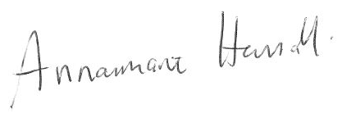
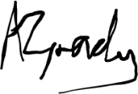
Alex Grady Annamarie Hassall MBE
Head of Whole School SEND Chair of Whole School SEND

Whole School SEND values

  - Inclusion
We believe that every child is entitled to an education and opportunities that enable them to enjoy, achieve and thrive at school and beyond into adulthood. As well as being enriching and enjoyable for its own sake, education must prepare all children for independent living, fulfilling employment and happy relationships. The children and young people who took part in our consultation exercise stressed that they want their teachers to place their views and wishes at the centre of decision making and to hold high aspirations for them.
  - Diversity
We believe that our best solutions are found from a diverse pool. We aim to bring education professionals together from across the broad continuum of provision. We value the contribution of those working in specialist and mainstream settings, be they support staff, teachers, SENCOs, or leaders. We equally value and seek the views of parents, carers, and children and young people, as well as other stakeholders with something to contribute to the discussion.
  - Strength based approach
We know that there is much good practice in the education system, but we also accept that SEND provision is not yet good enough everywhere. We want to identify and disseminate good practice and empower education professionals to feel able to develop and refine their approach to SEND provision. Research and evidence lie at the heart of the work that we do – so that we can be confident that resources are invested effectively, and we can measure the impact of our work. We respect that the experience of every learner is unique and that every education setting has a unique context – we do not believe that one size fits all. If you want to improve your SEND provision, then our suite of free resources can help you identify your strengths and areas for growth as well as the next steps you can take.
  - Collaboration
We believe that human connections and relationships are important. We aim to support local networks of education professionals to drive sustainable improvement to SEND provision. Our Regional SEND Leaders are working with existing local networks and influencers to create opportunities to reflect honestly on SEND provision. We create opportunities to share knowledge, ideas and experiences. We believe that we achieve more when we work together, and that collaboration is essential to deliver effective bespoke support to every child.
  - Integrity
We believe in innovation and creative approaches to challenges; and in investing our resources wisely to achieve meaningful impact. We are optimistic about the future of SEND provision, and realistic about the hard work that must be undertaken to achieve the improvements our children and young people deserve.

Executive summary

Whole School SEND (WSS) is a consortium of charities, schools and organisations committed to helping children and young people with special educational needs and/or disabilities (SEND) or learning differences reach their full potential. Individuals can join the WSS member community by signing up to receive the monthly e-newsletter. Hosted by nasen, WSS delivered the Department for Education SEND Schools’ Workforce Contract.
This report aims to review Whole School SEND activity in 2021/22 to evaluate progress against the contractual aims of the contract.

Key Findings

Engagement with the member community
There are several activities designed to engage with the member community and promote awareness of the WSS offer. A summary of the headline data is provided below:

Figure 1. Whole School SEND management information on key activities, 2021-2022

Quality outcomes and impact
‘Deliver high quality services which the sector incorporates into their practice and which lead to improvements in their provision’:
Over 95% of users are satisfied with WSS services.

Figure 2. As a result of accessing WSS services what outcomes have there been? Source: WSS membership survey (see appendix 1 for further information)

Evidence shows that engagement with WSS results in:
- Changes to individual practice
- Changes to the practice of others
- Changes to the leadership of/ or policy for SEND
Evidence indicates a range of impacts occur as a result of the outcomes above. The most significant impacts appear to be:
- More inclusive high quality teaching
- More inclusive ethos / culture in the setting
- Earlier and more accurate identification of SEN in the setting

Figure 3. As a result of the outcomes what impact has there been? Source: WSS membership survey

What we have learnt from the evidence
- Feedback gathered indicates that schools value and trust the resources and support from WSS.
- Members disseminated resources widely across settings which as a result led to changes in the practice of others as well as changes in the leadership of SEND.
- The WSS community consists of primary users who access resources and share across settings and secondary users who access the resources through the former.
- Digital delivery has benefits in that it resulted in a wider reach. However, the focus groups reported that in the past they had benefited from the rich discussions and networking opportunities from face-to-face events.
- Results from the surveys indicated that lack of time was the biggest barrier to engagement from practitioners in schools.
- The feedback from the professional development groups was overwhelmingly positive and provided detailed evidence of positive outcomes and impact on children and young people.
- The data shows that LAs who were part of the LA support project had higher membership rates and higher rates of attendance at live webinars.
- Feedback from the networking activity from the Regional Leads shows that as well as establishing relationships with local authorities, Regional Leads have been invited to join the steering groups for teaching school hubs; where this is the case, membership rates have further increased.
- Regional Leads report that the Whole School SEND ‘brand’ is supporting engagement across a wide range of networks; furthermore, there is a recognition across the sector that Whole School SEND is associated with high quality training and resources.
- Not all stakeholders are clear of the relationship between nasen and Whole School SEND particularly in relation to which resources are freely available and those which incur a charge.

Introduction
The aim of the SEND Schools’ Workforce contract is to embed effective SEND provision within school improvement to equip the workforce in mainstream and special schools, from foundation stage to sixth form, to deliver high quality teaching across all types of SEN. This involves ensuring the school workforce recognises the value of, and knows how to access, high-quality training and CPD opportunities, and can identify appropriate, evidence-based interventions. For information on governance and oversight of the project see appendix 2.

Objectives of contract
1. Equip the school workforce, across all 8 RSC regions in England, to prioritise and understand their responsibilities in relation to SEND and to share and embed good practice at individual and setting level within their CPD and school improvement plans, particularly in relation to SEN Support, early intervention, and effective preparation for adulthood.
2. Equip schools to meet their training needs in relation to SEND to improve provision through the delivery of targeted training packages within specific Local Authorities.
3. Build capability within the school workforce to ensure all professionals can contribute to excellent SEND provision at every point in their career by providing clear CPD pathways to support their development, including in relation to specialist provision.
Overarching KPIs
WWS0/1: Proactively engage with the WSS member community to maintain momentum and support effective delivery of wider contract priorities:
a) The WSS newsletter to reach at least 15,000 recipients by the end of the contract year
b) maintain a minimum of 20% open rate of WSS newsletter
c) maintain at least 10,000 followers on Twitter

WWS0/2: Deliver high quality services which the sector incorporates into their practice and which lead to improvements in their provision:
a) at least 90% of individuals who engage in activities are satisfied with the quality and felt the activity achieved its aim (including for specific target audiences where specified)
b) at least 80% of individuals who engage in activities report that they will incorporate their learning into their practice now
i. at least 90% of these individuals report that they have incorporated their learning into their practice, where this has been applicable or where they have been able to do this

Aims of the evaluation activity / strategy
The aim of this evaluation was to gather evidence from a range of sources to measure the extent to which Whole School SEND activity had met the objectives of the contract across the following strands:
- 1a: Regional CPD
- 1b(1): Sector led improvement
- 2a: Targeted Local authority support
- 5a Regional SEND team network building
The report on the evidence gathered is informed by Thomas Guskey’s five levels of evaluation:
- Participants’ reaction
- Participants’ learning
- Organisation and support
- Participants’ use of new knowledge
- Student learning outcomes
For the purposes of this evaluation, ‘outcomes’ refers to the change in practice following Whole School SEND input, whilst ‘impact’ is the effect on children and young people in the longer term as a result of the change in practice.
This report provides a summary of the evidence gathered from each of the contract strands. The evaluation of each strand follows the structure of the intent of the strand; the implementation activity; evaluation measures; an outline of what went well; evidence of outcomes resulting in change in practice; where available, the evidence of impact on children and young people and finally, key learning points to inform future practice.

Methodology
The work of Whole School SEND was evaluated using a mixed method of:
- Membership data
- Surveys of CPD participants and a wider membership survey
- Focus groups following the CPD survey and the membership survey
- A desktop review of the targeted delivery support documentation from the LAs who received support
- Surveys and one to one interviews with local authorities who had received the support
- Regional Leads’ evidence logs and participants learning journals for the professional development groups
- Additional evidence provided by members of the professional learning groups
- Interviews with regional teams

Consideration of the limitations of the evaluation
There are several considerations to note when reflecting on the findings of the report:
- The CPD survey and membership survey responses were from people who were already communicating with Whole School SEND in some way and therefore do not represent the sector as a whole.
- In addition, response to the surveys and the focus groups was voluntary and therefore may be subject to self-selection bias.
- Evidence of impact does not consider other factors which might have affected results.

Strand 1a Regional CPD

Intent: Aims of the strand
There is an overall need to improve the skills and confidence of the schools’ workforce to support the delivery of high quality SEND provision to pupils, particularly in mainstream schools. The aims of this strand were:
- to equip the school workforce, across all 8 RSC regions in England, to prioritise and understand their responsibilities in relation to SEND
- to share and embed good practice at individual and setting level within their CPD and school improvement plans, particularly in relation to SEN Support, early intervention and effective preparation for adulthood.
This strand built on previous activity undertaken in the 2018-2021 contracts, in which the regional SEND leadership teams established their presence within their regions and engaged with key stakeholders, such as Teaching School Alliances (TSAs), RSCs, local authorities, multi-academy trusts and local professional networks. Through working with these key stakeholders, the regional SEND leadership teams identified themes for targeted CPD interventions that would support the professional development of school staff around SEND. In 2019/2020 a face-to-face CPD programme was delivered across the RSC regions which resulted in high levels of engagement and positive feedback. In 2020/2021, due to the Covid-19 pandemic, this moved to a digital offer, via Zoom, which further increased reach and continued to receive positive feedback.
In 2021/2022 the programme continued to build on the success and engagement of the previous year. SEND professional development was addressed through digital CPD events which brought together a range of practitioners from across the sector, including experts in specific conditions and school improvement as well as the voice of teachers and leaders in schools. This provided an opportunity to build networks and spread good practice to address regional needs. This approach was closely aligned to the Standard for teachers’ professional development and where possible, incorporated learning from the EEF Remote Professional Development Rapid Evidence Assessment.
WSS National Coordinators gathered evidence to evaluate the impact of the CPD programme, as well as ensuring consistency and coordination of the offer across all regions, and alignment with other projects / activities. The aim was for the CPD programme to be delivered to at least 400 school-based attendees from each RSC region, reaching a total of at least 7,000. Attendance figures were calculated from both live webinars and recording viewings. This strand supported the contract aims of driving education institutions to prioritise SEND within their CPD and school improvement plans including facilitating greater links between mainstream and special schools (Aim 1).

Implementation: Summary of activity within strand
Using learning from the delivery across the 2020-21 contract period, each region planned and delivered two series of themed CPD events, with three sessions each (total of six webinars per region). Regional Leads received training from the Teacher Development Trust on effective CPD. Each series included an identifiable progression of learning and implementation activities within the structure of each session and across the series, to demonstrate the potential impacts of the learning alongside strategies to use to make positive changes to their provision. Participants were encouraged to attend all three sessions to benefit from the progressive design and to embed all aspects of the learning. Recordings of sessions continue to be available post-event for catch up and to allow attendees time to revisit and reflect on content and concepts.
In addition to the series, 8 additional standalone webinars were delivered to respond to emerging sector needs or to provide guidance on the effective use of WSS resources.
The themes for CPD were generated using information from the regional teams. Each team prioritised their top three topics, the information was collated and analysed by the head of Whole School SEND and a National Leader and each region was allocated their first choice for both a series and a standalone webinar. Themes identified were wide ranging and reflected both local and national priorities for the sector:
- Preparing for adulthood from the earliest years – high aspirations through all stages of education
- Improving outcomes for disadvantaged young people at SEN support
- New to the SENCO role
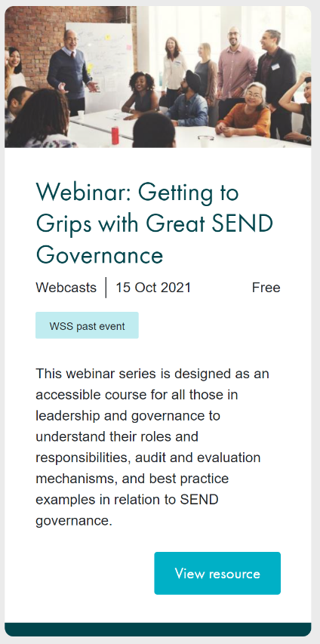
- Practical strategies for supporting speech language and communication needs
Figure 4. Screenshot from WSS website showing access to webinar recording
- Early identification and intervention
- The inclusive primary classroom
- Working with parents, carers and families
- Developing an inclusive, accessible and ambitious curriculum
- Getting to grips with great SEND governance
- The inclusive secondary classroom
- Leadership of SEND
- SEND in mainstream for early career teachers and beyond
- Leading CPD for inclusive SEND provision
- Perfecting preparation for adulthood
- Exploring opportunity and aspiration into FE and beyond
Titles for the standalone webinars included the following:
- An introduction to the Teacher Handbook: SEND
- Supporting learners with low incidence SEND
- Leading governance for SEND
- SLCN and DLD: what every teacher needs to know
- Supporting primary to secondary transitions
- Developing a shared ownership for SEND
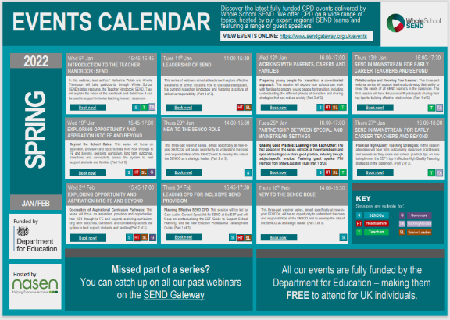
Attendance at webinars was open to all, regardless of region. Events were marketed through the CPD calendar on the SEND Gateway, social media and via WSS regional SEND networks and consortium partners.
Figure 5. Screenshot of interactive events calendar.

Evaluation
A range of evaluation methods were used to measure outcomes and impact including:
- Baseline poll - Upon joining a webinar, participants are asked to complete a baseline poll consisting of 3 standardised questions. There are 2 different baseline polls, an ‘initial’ poll which is used for standalone sessions and the first session in each series, and a ‘subsequent’ poll which is used for the second and third sessions in each series. The poll is optional, but participants are encouraged to complete it during the webinar.

- Post-event survey – Attendees are given the opportunity to complete a feedback survey after attending each live event. This survey is hosted on SurveyMonkey and is unique to each event. Participants are encouraged to complete the survey i) during the webinar via the ‘Chat’ function ii) in an automated follow-up email sent by Zoom 24 hours after the event start date and iii) on the SEND gateway resource page which hosts the recording and additional materials.

- Recording survey – People who watch the recording after an event has taken place are also encouraged to provide feedback via a survey. The survey is hosted on SurveyMonkey and the link is hosted on the SEND gateway resource page which hosts the recording and additional materials.

- Live webinar chat – Attendees are encouraged to share thoughts and questions during the live events via the webinar ‘chat’ function. Regional Leads and external speakers are able to respond to questions/comments in real time, as well as direct message specific attendees if required. Webinar transcripts are provided as part of regular quarterly evidence and reporting.

- Invitation to provide direct feedback – As part of the standardised WSS-branded powerpoint slide pack there is a slide which invites attendees/viewers to provide more detailed evidence of how the session has influenced their practice. This is also repeated on the SEND gateway resource page for each event.

- Longer-term impact survey – As part of the initial feedback surveys, participants are invited to provide their email in order to be contacted at a later date to see if and how the session has influenced their practice. This survey was sent in December 2021 to allow time for attendees to influence and implement new practice in their settings.

- WSS membership survey – A survey was sent to all recipients of the WSS e-news in January 2022. This survey included a section with questions about CPD webinars, including specific questions to gather examples of outcomes and impact in individual settings.

- Focus groups and 1:1 interviews – The longer-term impact survey and membership survey included the opportunity for respondents to engage with focus groups or a 1:1 interview to give further feedback about the impact of the webinars. Three focus groups took place, with representation from senior leaders, MAT inclusion leads, SENCOs, governors, parents and a Virtual School officer.

- YouTube comments – Recordings of all webinars are hosted on YouTube. Comments are enabled to allow for feedback from those who access recordings other than via the SEND gateway.

- Tweets – Tweets covering both promotion and feedback on webinars and events are collated and included as part of regular quarterly evidence and reporting. The WSS communications and SEND gateway manager also provides regular updates to the DfE contract team on communications and social media, including posts directly related to events.

- Direct communications to regional team – Some participants in events may contact the Regional Leads to provide feedback. Where appropriate, these communications are collated and included in regular evidence reporting.

What went well

Figure 6. Whole School SEND management system webinar data
The digital delivery model has increased attendance at WSS CPD events. Average live attendance this year was 68. This is double the average attendance figure at face-to-face CPD events in 2019/20. The series that attracted the most live attendees was ‘New to the SENCO role’ and ‘Practical strategies for SLCN’. The most popular standalone webinar was ‘SLCN and DLD: What every teacher needs to know’.
The attendance registers evidence the range of participants from across the school workforce. 53% of the school-based attendees are SENCOs. Most of the attendees at live webinars are from the primary sector (56%) and 79% of attendees are from mainstream settings. Compared to attendance last year, there has been an increase in the proportion of webinar attendees who are SENCOs or inclusion managers whilst the numbers of head teachers and senior leaders and of teachers and teaching assistants attending has dropped. There has been a larger proportion of Governors attending webinars this year. Webinars aimed directly at Governors (‘Getting to grips with great SEND governance’ series and ‘Leading governance for SEND: Using the WSS Governance review guide’ standalone) attracted the majority of this group, however school governors have also attended a variety of other webinars. School governors report that WSS CPD webinars support them in their role by increasing their own knowledge of SEND and providing them with questions to ask in their setting.

“As a governor the training has helped me to get teachers to rethink how they are looking at SEND. Webinars have given me confidence to challenge practice in the schools that I am governors in.”
CPD focus group, school governor

Attendance at both live and recorded webinars met and exceeded the target of 400 per region. A breakdown of webinar attendance is available in appendix 3.
During 2021/2022, webinar attendance has been monitored at a local authority level. This is to promote an equitable offer to the schools workforce in all regions and local authorities. The regional teams utilise the information to identify which areas are less engaged with WSS webinars and target promotion and networking activity accordingly. Throughout the year, reach has increased across a greater range of local authorities.

Table 1. Whole School SEND management system regional webinar dataB
 | no of LAs | % of LAs with webinar attendance: June 2021 | % of LAs with webinar attendance: Jan 2022 | % increase
EMSYH | 17 | 59% | 94% | 35%
ENELON | 15 | 80% | 100% | 20%
LWY | 25 | 72% | 96% | 24%
NORTH | 14 | 64% | 100% | 36%
SCNWLON | 27 | 78% | 96% | 18%
SESLON | 22 | 73% | 100% | 27%
SW | 16 | 63% | 94% | 31%
WM | 16 | 88% | 100% | 12%

There are now only four local authorities in the country with no attendees at a WSS webinar. These are Rutland, Knowsley, Kensington and Chelsea and Isles of Scilly; each in a different region.
Delegates continue to report high levels of satisfaction and intent to implement and share learning from the session:

Figure 7. Webinar attendee feedback. Source: post-event surveys

The offer of high quality, free to access, CPD for SEND is appreciated and new-to-role SENCOs report that the training supports them in understanding and executing their new role. SENCOs feel empowered to engage in further discussions around SEND with their senior leadership team and colleagues in school.

“I am just so grateful that such busy, well-trained and experienced professionals are able to offer this quality of training for FREE! I am new in role and feel so well supported by having access to this quality first training. Thank you!”
Webinar feedback survey, SENCO

“This was a really interesting and useful session. I feel a bit more empowered to be able to take these ideas forward to academic staff and senior team members.”
Webinar feedback survey, SENCO

The evidence indicates that headteachers and teachers continue to value WSS webinars. 96% of both headteachers and teachers who completed the post-event feedback surveys were satisfied with the session.
“It was fabulous. The hour went so quickly. Really refreshing to hear clarity rather than buzz words.”
Webinar feedback survey, head teacher

“Broad range of issues were addressed in a very practical way. I felt that the difficulties were discussed realistically and relate to real life in the classroom - not too academic or removed from reality.”
Webinar feedback survey, teacher

“This was my first event with you and I absolutely loved it - I feel so inspired which considering I'm a headteacher and it has been a very long year, is very impressive!”
Webinar feedback survey, head teacher

Delegates value being able to access recordings of the webinars after the live event; not only to reinforce their own learning, but also to share with colleagues, and it is reported that watching a recording of a webinar encourages attendance at future live webinars.
“…you can also point other people to them afterwards. You can refer colleagues to a really good piece of training.”
CPD focus group, virtual school officer

Outcomes
Evidence of outcomes resulting from attending WSS webinars was gathered through the membership survey and through focus groups:
94% of survey respondents reported having made changes to practice following attending a WSS webinar.

Figure 8. As a result of attending WSS webinars, what outcomes have there been? Source: membership survey.

Examples of outcomes include:
- Development of improved ‘early identification forms’, including assessments for academic progress, physical development and emotional well-being. This promotes more individualised support and earlier intervention.
- Sharing of tools and resources across the local authority services.
- Changes to attendance policy and removal of discriminatory attendance incentives.
- Consideration for preparation for adulthood being added to review forms at an earlier stage.
- Adaptations to training material for trainee teachers regarding deployment of teaching assistants.
- Governors feeling more confident to challenge practice in schools.

CASE STUDY – NEW TO ROLE SENCO, MAINSTREAM PRIMARY SCHOOL
What’s been valuable to me, is the ‘New to SENCO’ webinar series. Those sessions have been brilliant. I was able to use the learning to look at the systems and strategies that were already in place and take an informed approach to decide what needed to be changed and updated. It’s meant that I didn’t just rely on the systems that were already in place. We had lots of new staff and the WSS training has helped me to work with those teachers to understand their responsibilities regarding SEND. When I looked at interventions, I noticed that lots of children were in every intervention and never with their class teacher. I was then able to look specifically at those children and assess what they specifically needed and which were the most suitable interventions. Also, following the training, we have developed a system to evaluate the interventions currently running in school. Previously, the same interventions ran year on year.

One of the biggest things was looking at the roles and responsibilities for SEND of different members of staff. The ‘every teacher a teacher of SEND’ message has helped motivate and give confidence to teachers – they already have the skills and don’t need to be looking for something different or new for children with SEND. They can now see that what we do for our children with SEND can benefit all children.

There is now better identification of SEND in school. Teachers used to say things like “Can you just come and see this child, we think they are dyslexic.” Now we have systems in place for monitoring concerns and teachers are starting the graduated response themselves. The Teacher Handbook: SEND webinars have helped with this.

The accessibility of webinars has supported schools during this time [Covid]. You might be booked out to attend a webinar, but because of the current circumstances [staff absence due to Covid], you can be pulled to cover at short notice. Being able to watch the recordings is really useful.

Figure 9. Case study - New to role SENCO, mainstream primary school
“It’s helped me change the mentality around staff’s nervousness regards SEND provision … it’s helped me to understand what support I need to give the teachers … it’s given me the confidence to do it”
CPD focus group, primary SENCO

Impact
Webinar attendees report a range of impacts in their settings. The most common impacts reported are:
- A more inclusive ethos / culture in the setting
- More inclusive, high-quality teaching
- Earlier and more accurate identification of SEN
Figure 10. As a result of attending WSS webinars, what impact has there been for children and young people with SEND?

Examples of impact in schools include:
- Changes to behaviour provision, resulting in a reduction in the number of recorded uses of restraint.
- Children and young people with SEND spending more time in class with their teacher and less time withdrawn from class.
- A young person being provided with support and small stepped targets for independence to enable them to plan independent trips to the cinema.
- Children and young people with anxiety or medical conditions no longer feeling penalised by 100% attendance awards in the school where these abolished.

Barriers
We have identified a number of barriers:
- If there is a lower rate of engagement in a local authority area, fewer people in that area attend WSS webinars. Feedback from surveys and focus groups suggests that there are school-based professionals who do not yet know about the WSS webinars.
- 51% of the membership survey respondents had not accessed any WSS webinars; finding time to attend or watch recordings was the most common reason.
"Just not had the time to yet, but really do want to give these a go."
Respondent, membership survey

"Just time at the moment with so many staff off with illness/COVID."
Respondent, membership survey

- School-based respondents to surveys and in the focus groups reported that a lack of time and staff capacity are the biggest barriers to implementing learning from WSS CPD in schools. Throughout the year, schools have faced challenges in response to Covid. Staff who have strategic roles have been frequently used to cover classes, thus reducing the capacity for strategic activity needed to implement change.

- Feedback from the post webinar surveys indicates that some attendees felt some sessions lacked interaction and could be ‘didactic’. There were some reports that it was difficult to access the series pre-reading. In general, live attendance drops off through a webinar series. There have been two exceptions to this: Working with parents, carers and families (SW) and Leadership of SEND: Building a culture of collective responsibility (NORTH).

Key learning
- Take into account that webinar attendance was highest between September and October and lowest between November and December.
- Continue to include examples of how to put the pedagogical theory into practice in the school setting. Delegates value having resources to ‘take-away’ and implement or adapt for their own setting.
- Ensure CPD promotes active engagement from the participant and that documents referred to for pre- / post- reading are easily accessible.
- Consider a blended approach to CPD delivery, if possible. Live webinars, face-to-face sessions and access to recorded delivery are all valued by the member community. Live attendance at webinars is lower than last year but recording views are higher indicating a change in the way schools are engaging with online learning. 33% of people who booked went on to attend the live webinar (3,696 live attendees from 11,242 bookings).
- Respond to member feedback which indicated that ‘the inclusive classroom’ is the most popular topic for future CPD. ‘Social and emotional wellbeing’, ‘leadership of SEND’ and ‘early identification and intervention’ were also popular choices.
- Consider further ways to target the schools’ workforce beyond SENCOs, while maintaining the highly regarded support currently available for SENCOs.
- Continue to track which areas of the country have lower rates of engagement with WSS CPD and use regional networking to grow reach into these areas.

Conclusions
The evidence gathered indicates that WSS CPD webinars are highly regarded by the practitioners who have accessed them. The reach of the CPD webinars is growing across the 8 RSC regions in England and there is clear evidence that the WSS CPD offer is supporting the school workforce to prioritise and understand their responsibilities in relation to SEND. Evidence has been gathered which demonstrates how schools are embedding good practice at an individual and setting level within their CPD and school improvement plans. Examples of evidence collected show impact in schools, particularly in relation to improved identification of SEN, improvements in inclusive high-quality teaching and more effective preparation for adulthood.

Strand 1b (1) Sector-led improvement Professional development groups

Intent: Aims of the strand
The aim of the project was to propose and deliver a programme of regional online sector-led improvement activities (through professional development groups) to help foster a culture of reflection, challenge, and support between peers and across the sector, particularly in relation to SEN support, early intervention, and preparation for adulthood.
The knowledge, skills and understanding to improve outcomes for children and young people with SEND exists, however, this is not spread evenly across and between schools. Outcomes are poorer with attainment lower than for children and young people without SEN whilst absence and exclusion rates are higher for those with SEN WSS aims to equip the school workforce, across all 8 RSC regions in England, to prioritise and understand their responsibilities in relation to SEND and to share and embed good practice at individual and setting-level within their CPD and school improvement plans.

In order to do this, a model of evidence-informed, sector-led improvement activity was designed to contribute to the spreading of the effective practice that exists; a collaborative, iterative process using small, focused professional development groups to enable the deepening of understanding and embedding of effective practice across schools. The facilitated sessions were planned to run throughout the contract year, but the networks and groups built through this project have the potential for longevity and sustainability.

The project brief specified eight regional groups of approximately ten participants to be established, led by WSS Regional Leaders, and scheduled to meet online six times in the year, each session being interspersed with individual/school group professional conversations with a Regional SEND Leader.
Each group focused on a theme pertinent to SEND, including but not limited to, preparation for adulthood and employment, and SEN Support and early identification, and was comprised of school-based professionals in a range of roles. The groups were designed to have the autonomy to drive their own programme of intervention and so be more authentically sector-led, be more likely to commit to a year-long ‘network’ and be able to align this opportunity with their current/planned school improvement planning, to focus on areas for improvement which they feel would have the most impact across the year, and to secure take-up. Participants established a baseline around specific areas for development in their schools and addressed and discussed/reviewed these together. It involved an iterative process of trialling and adjusting over time (plan, do, review).
The structure of this sector-led improvement work means that approximately 80 schools/education professionals would benefit from an intensive, high-quality programme of professional development for SEND. The expectation was that this would result in measurable impacts within their schools on both outcomes and experiences of their learners with SEND, dependent upon the focus theme of each group. It was expected that there would be secondary benefits of embedding SEND within schools’ improvement plans over the longer term, by growing the confidence and competence of teachers in SEND, consolidating the strategic role of SENCOs and other SEND professionals, contributing to the effective deployment of teaching assistants, and potentially encouraging SENCO and other SEND professionals to aim for headship and/or special school positions, where recruitment is often challenging. We also hoped that the creation and facilitation of these groups would encourage sustainability beyond the end of the programme, as strong networks and relationships would have been developed within local areas.
Progress towards the targets outlined above was measured through participant feedback gathered throughout the year based on, e.g. their confidence in supporting pupils with SEND, the impact they think engagement will have / has had on their practice, the impact on the practice of others.

Implementation: Summary of activity within strand
The programme was designed to respond to regional needs to ensure activities align with LA-identified needs for schools. Groups used existing resources to support activities and discussions (e.g., WSS SEND Review guides).

The groups were open to participants in the following roles, who may be from different geographical areas within the same or neighbouring RSC region, and whose settings have different types/levels of need:
  - Leaders from mainstream schools
  - Leaders from special schools
  - Teachers from mainstream schools
  - Teachers from special schools
  - Teaching Assistants from mainstream and special schools

Feedback from participants was gathered to be shared with the members of the groups and wider across the sector, e.g. through case studies, on the impact of the professional development group’s activities on their practice. The next step is for examples of contextually effective practice to be identified, reviewed and shared to disseminate the learning from the groups in an easily accessible format on the SEND gateway.
Ten Twitter chats were held across the year, to promote discussion on the identified themes across the sector.
Representatives from 80 schools (10 per region) were recruited to the professional development groups to meet twice per term to reflect on their practice, plan improvement activities, get support on effective implementation and share all resulting learning.
Before recruitment, eight themes were identified as current priorities for focus for the professional development groups in consultation with the regional teams, the Head of Whole School SEND and WSS National SEND Leaders, in conjunction with nasen SEND Leads
After reviewing the open recruitment register of interest, there was a clear preference for two of the themes. As the project was designed to be sector-led, and the two most popular themes were excellent over-arching routes to meeting the contract aims the plan for the project was adjusted to reflect the focus on two themes:
- The Inclusive Classroom: High-Quality Teaching in Every Setting
- Leadership of SEND: Building a Culture of Collective Responsibility

Based on the preferences in the regional Expressions of Interest, the theme of ‘Inclusive Classroom’ was allocated to five regions:
- East Midlands, South Yorkshire and the Humber (EMSYH)
- West Midlands (WM)
- East of England and North East London (ENELON)
- South East England and South London (SESLON)
- South West (SW)

Based on the preferences in the regional Expressions of Interest, the theme of ‘Leadership of SEND’ was allocated to three regions:
- North of England (NORTH)
- Lancashire and West Yorkshire (LWY)
- South Central England and North West London (SCNWLON)

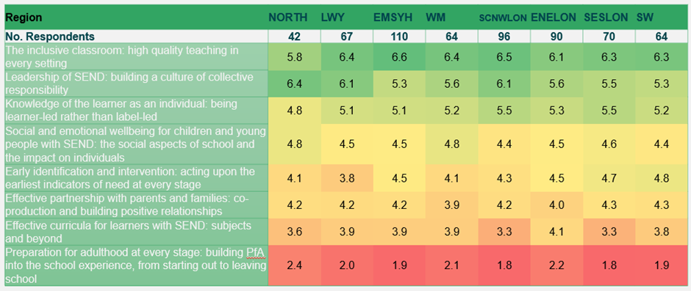
Figure 11. PD recruitment register of interest

  - Recruitment
Recruitment for the project was launched in May 2021. An advert giving an outline of the project was developed and shared through WSS and nasen social media. This included the information that, to support them to release members of staff, participating schools would receive £1000 on the submission of evidence of completion of the project. Interested applicants were asked to complete an online Expression of Interest Form giving information about their role, school setting and preferred focus for the professional development groups.
A total of 606 Expressions of Interest were received. Due to the high volume of interest in joining the groups, a selection process was necessary to narrow down candidates. The selection criteria are detailed in Appendix 4.
After the selection process, selected applicants were emailed to offer them a place. Potential participants were sent a Participation Information Pack and Agreement document to outline the requirements and expected time commitments of the project and asked for a formal commitment from both the participant and their Headteacher/Chair of Governors.
In total, 154 applicants were contacted to offer a place; 84 were able to commit to the project from 80 different schools. 51 applicants did not respond to the offer to take part in the project.
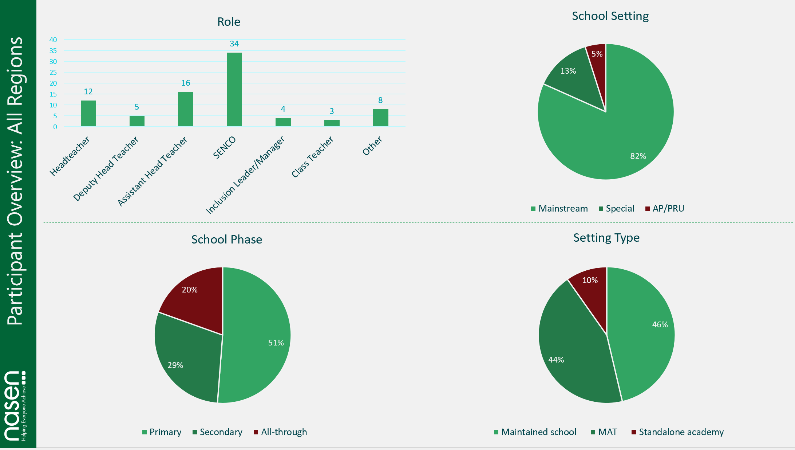
Figure 12. PD group participant overview: All regions

  - Regional Lead Training
The Regional Teams were asked to identify one Deputy/Regional Lead in each region who would lead the Professional Development projects and facilitate the group sessions.
These Regional and Deputy Regional Leads were trained in effective facilitation of professional development and coaching in a one-day virtual meeting led by Julie Greer, Headteacher of Cherbourg Primary School, member of the Anna Freud Centre Quality Assurance Group, Visiting Fellow at the University of Southampton and Founding Fellow of the Chartered College of Teaching. Further training was provided by the head of WSS and National Coordinators at a Regional Leads planning day prior to the first group sessions.
  - Delivery Planning
Regional Leads were asked to identify the dates and times for group meetings in order for applicants to be provided with these before committing to the project. The rationale behind this was to support applicants with balancing workload and capacity alongside their school roles.
Two documents were created by the central team to be provided to project participants to support them with their evidence collection and improve engagement with the project.
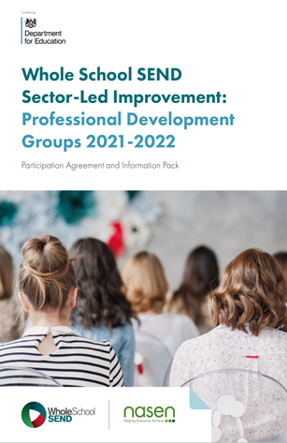
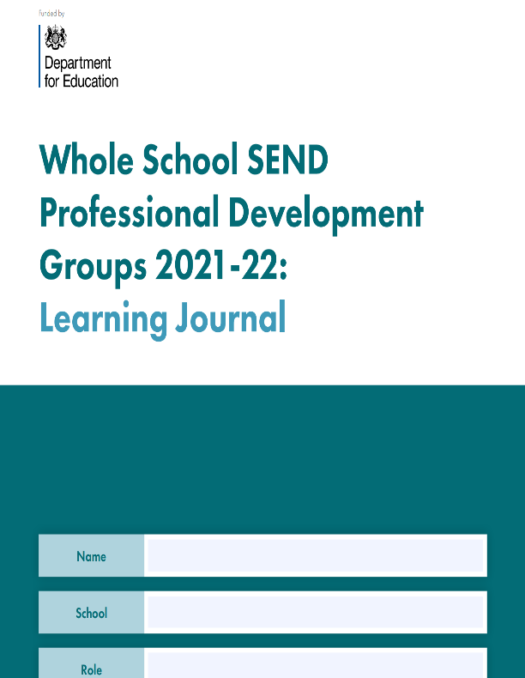
Figure 13. PD groups participation agreement and information pack
Figure 14. PD groups participant learning journal
Due to the ongoing Covid-19 situation, group meetings were planned to be delivered virtually via Zoom.
  - Project Delivery
  - Professional Development Groups
Between September 2021 and February 2022, a total of 6 group meetings were held virtually with each regional Professional Development Group (total of 48 meetings across the project).
Interspersed with the group meetings, each participant received at least 4 individual professional conversations to support the implementation of the project with their allocated Regional Lead; those members who needed additional support received up to 2 further meetings.
  - Twitter Chats
Ten Twitter chats were planned to promote the professional development groups and promote further sector engagement.
Each Twitter chat took the form of a series of questions based around an overall theme, posted to the main WSS Twitter chat (@WholeSchoolSEND) over the course of an hour. Hosting the discussions on Twitter allows for the WSS member community to engage with their Regional Leads and consortium partners.
Each Twitter chat featured a WSS Regional or Deputy Regional Lead, a member of the nasen Education team and a representative from a consortium partner or the wider sector. Themes for eight of the Twitter chats were based on the provisional themes developed for the Professional Development groups, the remaining two themes were based on the delivery and implementation of the groups themselves.
Twitter chats were scheduled to take place during term time evenings to maximise the possibility for the sector to engage.
The themes for the Twitter chats are listed below:
- Preparation for Adulthood at every stage
- Effective Partnerships with Parents and Families: co-production and building positive relationships
- Knowledge of the learner as an individual: being learner-led rather than label-led
- Leadership of SEND: Building a culture of collective responsibility
- Social and emotional wellbeing for children and young people with SEND: the social aspects of school and the impact on individuals
- Early identification and intervention: acting upon the earliest indicators of need at every stage
- The importance and impact of professional development groups
- Effective curricula for learners with SEND: subjects and beyond
- What makes for effective SEND CPD
- The inclusive classroom: high quality teaching in every setting

Evaluation

The following evaluation measures were implemented during the project:
- Open recruitment – Initial recruitment for the PD groups was open to all school practitioners across all school phases and settings to gauge interest in this style of professional-development opportunity. Data was collected from all applicants to analyse demographics of those interested in the opportunity.
- Initial pre-project survey – Participants were required to complete a survey at the start of the project (before the first group meeting) which examined their current knowledge, confidence and thoughts around SEND within their setting.
End-project survey – Participants were required to complete a survey at the end of the project (after the final group meeting) which examined their current knowledge, confidence and thoughts around SEND within their setting, and to provide feedback on the project itself.
- Regional SEND Leader (‘RSL’) Evidence Log – Regional SEND Leads facilitating each PD group were asked to complete an evidence log over the course of the project, collecting evidence of discussions and reflections on the project.
- Participant Learning Journal – Participants were asked to complete a Learning Journal as an evidence log and to support their professional development over the course of the project, collecting evidence of discussions, their reflections on the project and planned actions resulting from the sessions.
- Twitter chat statistics – Statistics and data relating to the 10 Twitter chats were collated to evaluate reach and impact of the themes of the project outside of the specific PD groups.

What Went Well

The response from all Regional Leads and participants was positive. Every region identified the professional development groups as being one of the most valuable strands of work for year 4 of the contract both in terms of the process of delivering the projects and the outcomes and impact. The one-to-one professional conversations were identified as a particular strength of the project. Listed below are some of the comments from the Regional Leads’ evidence logs:
- Progress has been tangible both enthusiasm and engagement has increased as members are now focussing on specific areas identified from their evidence base.
- Whilst two themes were identified some of the strongest projects have a significant overlap between both: distributed leadership and the inclusive classroom.
- The project supported being able to work with and have direct contact with all staff, this was something that had not been possible during covid.
- Participation in the project resulted in improvement in staff confidence at all levels.
- Leading on this has been as much of a learning experience for me as it was (hopefully) for my group
- All participants reported that they gained from participation in the project both in terms of their own professional development and for their schools.
- The project provided a framework for implementing change.
- The profile of SEND has been raised in many settings.
- The leaders have shared in many of the settings that during their journey other aspects of teaching and learning or leadership have been uncovered and the project has branched out into further aspects. This has allowed for challenge and clear future planning with support from the PD leader.
- The 1:1 sessions were really engaging and powerful to steer/ coach and mentor.
“I must say it has been one of the most purposeful and useful things I have been a part of in my professional career.”
Professional Development Group Member

“The chance to have the time and ‘headspace’ to talk about SEND and children should not be underestimated. It is so powerful and energising, especially against the backdrop of the pandemic.”
Professional Development Group Member

Outcomes

Members of the Professional Development groups reported the following outcomes in the end of project survey:
- 98% felt that their understanding of SEND topics and issues improved because of participating in the group
- 91% felt that their confidence with supporting children and young people with SEND improved as a result of participating in the group
- 29% rated their schools’ current provision for SEND as ‘Very Good’ (compared to 17% at the baseline) and 64% as ‘Good’ (compared to 55% at the baseline)
- 100% reported that SEND is now prioritised within school improvement planning
- 80% felt more able to influence their school’s support and provision for children and young people with SEND as a result of participating in the group
- 100% feel that they understand their individual responsibilities in relation to children and young people with SEND

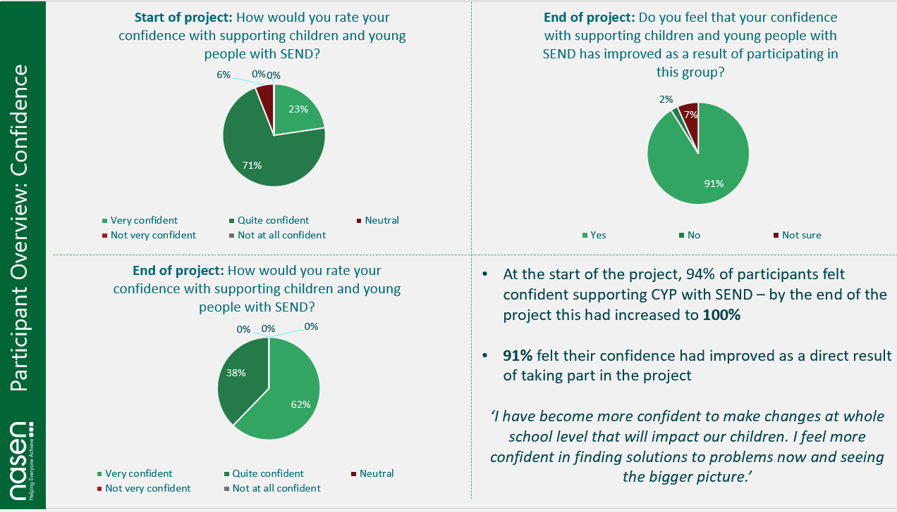
Figure 15. PD groups participant overview: confidence

Impact

Some examples of the impacts resulting from the participants’ projects:
- Improved support plans to inform staff of student needs resulted in a reduction in behaviour points, which are used to monitor students’ negative behaviours.
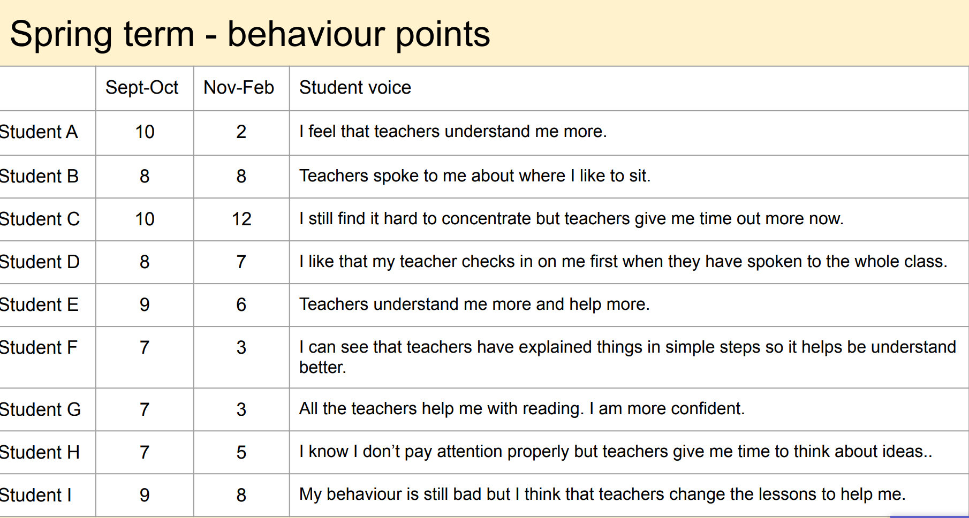
Figure 16. PD groups example of impact: reduction in behaviour points
- Development of the Engagement Model in a special school to align with long term targets in one child’s EHC plan focussing on depth of knowledge resulting in an improvement in results.
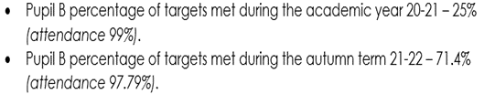
Figure 17. PD groups example of impact: increase in percentage of EHCP targets met
- A whole school approach to support teaching assistants in providing support and scaffolding for students with feedback to teachers resulting in improved academic outcomes for pupils with SEND.
- A reading project to which also helped to support appropriate life skills for SEND pupils.
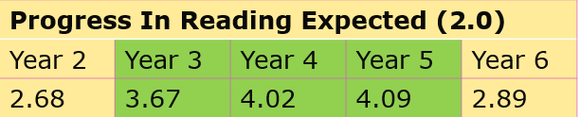
Figure 18. PD groups example of impact: increased progress in reading

Barriers

We identified two potential barriers prior to the project:
- Virtual delivery was identified as an issue by the Regional Leads due to the limitations that this can cause to the networking aspect of the project. However, each region was allocated a Zoom account and the Leads were able to incorporate break out discussion into their sessions. Although Zoom is a virtual platform there is a facility for the host to separate participants into smaller groups to facilitate discussion. Secondly, the virtual format enabled more convenient communication between members who were located some distance away from one another geographically across a region. This was useful when staff absence was high in schools and leaders had little capacity. In addition, the one-to-one professional conversations enabled Leads to establish a relationship with each member and allow time for further discussion on specific issues.
- Covid pressures were anticipated due to the higher possibility of staff absences, need for project participants to focus on school roles, less time allocated within schools to training and professional development.
  - Covid did present a barrier both in terms of members leaving the project and attendance at sessions. Of those who left the project most were either head teachers who had to deal with Covid pressures in their schools or new SENCOs who were unable to balance the strategic work of the project with their operational responsibilities. None of the groups had full attendance at every session.

Key learning

Both the members’ learning journals and the Leads’ evaluations provided comprehensive information on some of the key learning:
- Utilise the initial one to one conversation to identify a clear focus for the project and support members to work through their ideas and as a result narrow the scope to fit the time frame and possible outcomes.
- Encourage members to keep projects small but to choose something that is transferable and can be scaled up.
- Projects such as using technology to support inclusive practice have highlighted the need for training on the use of assistive technology.
- Before identifying projects within the themes be prepared to support members to review their identification and assessment of need.
- Develop collegiate support by matching schools with similar projects to provide the opportunity for better communication outside of the project to support one another.
- Consider the optimum timing of the project; the first meetings ideally need to take place in the summer term as this is the point when schools are writing their development plans. Information on the evaluation of outcomes is available at the end of the project but measurements of impact on children need more time as this usually takes longer to become evident.
- Consider focusing on improving existing systems within schools through distributed leadership.
- Use team members for the professional conversations to match people with similar expertise.
- Consider implementing some of the changes suggested by the Regional Leads:
  - Information provided to group members in advance to be clearer that this is a largely independent piece of work that will be facilitated and supported by the region and their peer group
  - Information provided to group members in advance to be clearer that this should be a piece of work that they need to undertake anyway, but with the benefit of structure, support and guidance – it should not create a significant amount of additionality and should be supportive of their school or department improvement plan etc.
  - Head and or governor support was seen as essential to the success of the project.
  - Many settings would have liked to meet last academic year in preparation to start the project this academic year and have 12 months to deliver it.

Conclusions

The evidence gathered from the Leads’ evaluation logs and the members’ learning journals indicates that the project resulted in improvements in members understanding of SEND and thus their confidence so that they were able to support teachers and the wider staff to understand their individual responsibilities for children with SEND. Moreover, prioritising SEND within their school improvement planning led to further improvements in their provision.
It fulfilled its aims of supporting a culture of reflection, challenge, and support between peers and across the sector. The range of projects was wide, and members were able to provide rich evidence not only of outcomes for the wider workforce but also, and more importantly, the impact on children and young people in relation to SEN support, early intervention and preparation for adulthood as well as the benefit to their own professional development.

Strand 2a Local Authority Support

Intent: Aims of the strand
The aim of this strand was to improve strategic planning and SEND provision at school and LA level by delivering targeted packages of professional training to local authorities. The strand built upon previous activity undertaken in 2020-21. It supports the wider contract aim of driving schools to prioritise SEND within their CPD and school improvement plans (Aim 1) and specifically to meet their training needs in relation to SEND to improve provision within specific Local Authorities (Aim 2).

The targeted delivery agreed with LA officers, DfE SEND Advisers and WSS, supports local areas to improve leadership and governance of SEND, the implementation of High-Quality Teaching strategies and the use of data to inform strategic planning. Thereby it improves the lived experience children, young people and their families and contributes to the reduction of variation in standards of delivery nationally. The offer utilises the expertise of the national and regional WSS teams.

Implementation: Summary of activity within the strand
LAs are primarily identified for this support through the programme of Ofsted/CQC Local Area inspections which determine how well the 2014 SEND Reforms are being implemented. Some of the LAs which have been found to have weaknesses in relation to the schools in their area, including varying success around good outcomes for pupils with SEND, commitment to inclusion, accurate identification of needs, and absence rates and exclusions, and were required to produce a Written Statement of Action, were designated by the DfE for this support. LAs which have not yet been inspected may be designated where exclusion rates or other data or information from SEND Advisers indicated that there are issues with inclusion which could be addressed through this support. In addition, as a continuation of this work, LAs that have previously interacted with the support and where it has had significant impact, may be nominated for continued support.
Final agreement on which LAs were nominated to receive support packages was reached through discussion with DfE SEND Advisers and a targeted delivery support proposal (See Appendix 5) was developed in partnership with the SEND Adviser, DfE Case Lead within the SEND Improvement and Intervention Unit (SIIU), WSS Regional SEND leader and LA. Each support package addressed specific issues to an agreed scope and aligned with other delivery partners working with the same LAs (e.g., through other DfE contracts), to ensure LAs had capacity to engage fully and effectively. This offer was then submitted to the DfE Targeted Delivery Support (TDS) Moderation Panel for review.
Fifteen local authorities were identified by DfE for support from WSS (see Appendix 6). One local authority support package was delivered and completed in the summer term 2021, seven received a support package during the autumn term 2021 and the remaining seven worked with WSS during the spring term 2022. One LA which had been nominated for support in the previous contract year was removed from the cohort, following statutory direction being issued to the council in October 2021. In discussion with the DfE SEND adviser for the region, it was agreed to reallocate the support package from WSS. Therefore, an alternative LA was nominated to receive support.
Each LA package of support was developed and delivered using the following process:

Evaluation

A range of evaluation methods were used to gather data to measure outcomes and impact. These are outlined below:

- Baseline poll - Upon joining a session, participants were asked to complete a baseline poll consisting of 3 standardised questions. There were 2 different baseline polls, an ‘Initial’ poll which was used for standalone sessions and the first session in each training programme and a ‘subsequent’ poll which was used for part 2 of a session in each training programme. Completion of the poll was optional, but participants were encouraged to complete it during the session.
- Sustainability session with Local Authority – this meeting took place between WSS and the LA at the end of the training programme. The purpose of the meeting was to ensure that the learning is embedded in practice in schools and makes a difference. Project outcomes were reviewed, and strategies put in place to achieve long term impact and sustainability.

- Post-training survey - Attendees were given the opportunity to complete a feedback survey at the end of the training programme. This survey was hosted on SurveyMonkey and there were 3 different surveys to cater to the following audiences: 1) LA, 2) School (i.e., Headteacher/Principal) and 3) All other individual participants (i.e. SENCO, Governors). Participants were reminded to complete the survey a few days before it closed.

- Follow-up focus groups / 1:1 interviews – as part of the surveys, LA Leads, headteachers and other individual participants were given the opportunity to consent to taking part in focus groups or 1:1 interviews to evaluate the project further. Four focus groups and three interviews took place attended by head teachers, senior leaders and SENCOs. Two meetings took place with LA representatives.
- Live meeting chat - Attendees were encouraged to share thoughts and questions during the live session via the meeting ‘Chat’ function. Regional Leads and LA colleagues were able to respond to questions/comments in real time, as well as direct message specific attendees if required. Meeting transcripts were provided as part of regular quarterly evidence and reporting.

- Direct communications to Regional Team and Local Authority – Some participants in the sessions contacted the Regional Leads and/or LA to provide feedback. Where appropriate, these communications are collated and included in regular evidence reporting.
For the purpose of this report, the evaluation has been carried out for the completed packages delivered during the summer and autumn terms 2021.

What went well

Figure 19. LA support: engagement and feedback data
2,519 school based practitioners (including governors) attended training sessions provided by WSS across the 8 local authorities. Responses to the feedback survey were received from all three groups: LAs, headteachers and other individual participants (SENCOs, teachers). LA Leads, headteachers and other attendees report high levels of satisfaction and intent to implement the learning into their practice.

“The training was fantastic - as a head teacher gave me such insight into the role I should be playing for our SEND children and enabled me to engage at a deeper level with my SENCO.”
Headteacher, Sefton

The themes of the training packages have particularly supported new SENCOs to understand their roles and review current practice in their settings.
The local authorities that received support during the autumn term 2021 had all been engaged with the WSS project during the previous contract year. Following the positive feedback and demand from schools not involved, it was agreed with the DfE advisers that improvements could be embedded across the LA by an additional programme of support, building on the first, in Year 4. Local authorities reported that schools that had already received the training first time round were keen to be involved again to revisit the learning / send other staff.
The SEND in a Nutshell document (See Appendix 8) was a particularly valued resource as it allows schools to have a one-page strategic overview of SEND.
The LA strand has led to greater membership sign-up and increased attendance at WSS webinars. (See figures 20 and 21)
Figure 20. Average WSS membership is higher in LAs involved in strand 2a
Figure 21. Webinar attendance figures are higher in LAs involved in strand 2a

Outcomes

Evidence from the focus groups confirmed changes are happening in schools. Participants reported on changes to their own practice, the practice of others and to the leadership of SEND. Feedback from both the survey and focus groups identified that having the ‘SEND in a Nutshell’ resource has prompted headteachers and SENCOs to interrogate their school’s identification data in more detail than previously. This has led to the following outcomes:
- More strategic meetings between SENCOs, senior leadership teams, Governors / Trustees, external agencies. Schools report that sharing this data with a range of stakeholders is prompting reflective discussions and deeper consideration for their provision for children and young people with SEND.

“By learning how to analyse our identification data, we have changed our practice in how we identify children.”
Headteacher, Medway

“We have been provided with a brilliant tool (Nutshell) to be assisted with knowing our demographics and further analysing our data…I am preparing the governors' report and I am so excited to include this document too. “
SENCO, Luton

- Some SENCOs having a more strategic role within the school. Headteachers and SENCOs reported that they have allocated more non-contact time (Code of Practice 6.91) to the SENCO to utilise the ‘SEND in a nutshell’ document to inform planning. However, there are still SENCOs who do not have enough non-contact time to work strategically; some only have one or two hours per week for the SENCO role. These SENCOs reported that the support package added pressure to their workload and that the training should have been delivered to all staff. Despite being offered to all staff, it was often only the SENCO who attended the training.
“I feel this is a lot of work for a teaching SENCO to complete. I am a full time teaching SENCO… . I want to be able to use the resources as they are excellent and will help us as a school in a very positive way but I am feeling very overwhelmed when I can complete these things.”
SENCO A, Staffordshire

- When head teachers and SENCOs attended the training together, understanding about distributed leadership and a whole school approach to SEND has increased.
“Before I was guilty of saying – that’s not me, SENCO can deal with that, but now I am a leader of SEND.”
Headteacher, Staffordshire

“…subject leaders are now taking more responsibility for SEND in their areas.”
SENCO B, Staffordshire

- The session recordings enabled schools to disseminate the key messages more widely in their settings. One SENCO shared how she was able to network with other SENCOs in the MAT and use the recordings to present a case for change to SLT across their schools.
“Because we were saying the same thing and we had the back-up of the recordings, we think SLT were more responsive to it. The recordings are really helpful.”
SENCO C, Staffordshire

Feedback from the headteacher survey indicates intention to implement changes to the leadership of SEND, for example:
- To complete self-evaluation of SEND provision using WSS SEND review guide
- To review the school’s SEND register
- To deliver further SEND related CPD for all staff
- To embed the principles of a whole school approach to SEND

Impact

Feedback gathered during the focus groups and 1:1 interviews indicates that several schools involved in the WSS local authority support project can evidence examples of impact for children and young people in their settings:
- Earlier and more accurate identification of needs– one SENCO reported that fewer children are now classed as ‘other’ on the SEND register. Another described how, previously, many children were not identified as having SEN until Key Stage 2. Comparison with local and national data encouraged the school to review their identification procedures and more children are now identified in Key Stage 1. This allows them to access appropriate earlier intervention and support.
- A more inclusive ethos in the setting. Head teachers and SENCOs reported that by sharing the breakdown of need across the school, staff have been reminded about their responsibility for children and young people with SEND in their class(es). They report that teachers are less likely to withdraw pupils with SEND from classes.
- Analysis of the primary categories of need in has resulted in changes being made to the provision available to pupils in schools. One SENCO, from Cumbria, explained how their data highlighted a high proportion of pupils with SEMH needs. This led to commissioning an additional emotional literacy support assistant and external support from an agency with SEMH expertise.
- Improved high quality teaching for children and young people with SEND. After evaluating their provision using the WSS SEND Review Guide, school-led changes have been implemented. Children with SEND are now spending more time in class with their teachers, rather than being withdrawn to work with a teaching assistant. Interventions are being reviewed and more targeted at individual need, leading to changes to the school level policy.

CASE STUDY – ASSISTANT HEADTEACHER, MAINSTREAM SECONDARY SCHOOL
At our school, students who have difficulties completing homework are issued with a ‘homework agreement’. This signals to all teachers that before a sanction is issued for not completing homework, the teacher should discuss the issue with the child’s allocated key worker. The key worker acts as a liaison to see how the pupil can be supported to complete the homework. Before being part of the WSS project, many staff overlooked the homework agreement and blanket sanctions were issued to any student who did not hand in homework.

I was able to use staff training sessions to disseminate the WSS training I had attended. Through this training teachers have realised that they are responsible for making reasonable adjustments for students with SEND and that it is their duty to give each child the tools they need to be successful.

Now, staff are more likely to adhere to the homework agreement policy. I am receiving an increase in emails from staff – “This pupil hasn’t done their homework, what can I do to engage them?”. This often opens up communication with parents, allowing a more collaborative approach to supporting pupils with SEND. More pupils with SEND are now attending ‘homework club’ and being helped to complete their homework and they report that they appreciate the support they are receiving. Homework club is getting busier and busier.

Being able to use the WSS training in school has helped to reduce the culture of ‘that’s the SENCOs issue’. Every teacher, leader, governor being a leader of SEND is promoting conversations with other members staff; this is everyone’s responsibility. Using the WSS resources has enabled staff to see it’s not just me who’s saying this.

- Increased engagement of children and young people with SEND: Learners with SEND are now routinely involved in pupil voice interviews and are able to give their views on the provision made available to them.
A SENCO from Staffordshire described how a pupil in Y3 has said that his life is now ‘less stressful’ because he is now allowed to use a printed script rather than cursive handwriting. This is as a result of pupils with SEND now being routinely included in work scrutiny and pupil voice interviews.

A case study example of one of the local authorities involved in this project is available in appendix 9.

Barriers
A number of barriers have been identified:
- Administration capacity within the local authority. WSS relied on the local authority teams to distribute meeting invitations, resources, feedback forms. This led to inconsistency in the amount of notice that schools were given for training sessions and the length of time schools were waiting to receive resources.
- Some feedback received highlighted that there was a conflict between the message being given by the local authority and that of the MAT central team. This left some schools in a challenging position trying to meet the demands and expectations of both parties. However, other local authorities reported positively about how MATs had engaged with the project.
- Where SENCOs are not given sufficient time for strategic work, or the school does not yet have a shared responsibility for SEND, SENCOs can feel overwhelmed by the prospect of finding time to implement the new tools / resources in their settings.
- Even when SENCOs are part of the senior leadership team, attendance at SEND training is often devolved to them, which can dilute the message of distributed leadership and shared responsibility of SEND.

Key Learning
- Strengthen the requirement for headteacher and senior leader engagement in the training alongside the SENCO in order to reinforce collective responsibility for SEND.
- Ensure that LAs participate as full partners rather than recipients in the programmes of training so that there is stronger engagement from schools.
- Encourage LA school improvement services to model collective responsibility for SEND.
- Build long-term sustainability into programme planning and delivery.
- Continue to provide recordings of training sessions because they are valued by schools and aid further dissemination of learning.
- Encourage LAs to disseminate messages from WSS training to all schools to promote consistency.
- Support LAs to sustain and embed changes that have already taken place through regional team networking.
- Consider the trends in issues to be addressed and training requested across the LAs when planning future support. Common intended impacts were:
  - Reduction in absence and suspension / exclusion rates of pupils with SEND
  - Reduction in rejections of statutory assessment requests through increasing appropriateness of requests
  - Increase in the number of pupils with EHCPs having their needs met in mainstream schools
Many local authorities requested the following training sessions:
- Every leader a leader of SEND
- Every governor a governor of SEND
- SEND self-evaluation and review
- SEND in a nutshell
- High quality inclusive teaching and learning strategies

Conclusions
The evidence shows that working strategically with a local authority can improve SEND provision at both a school and LA level. Evaluation of the support packages suggests that, across the country, LAs are identifying the need for tools to enable schools to evaluate their practice in relation to SEND. There is an understanding from LA colleagues that to effect change in schools, we must start by addressing the responsibilities of SEND at a school and system leadership level. It is recognised that to embed improvements in provision for children and young people with SEND, school governors / trustees must understand their responsibilities. LAs want to give schools a clear message about what high quality inclusive teaching and learning looks like and schools welcome this consistent approach.
Schools have adopted revised ways of working based upon a wider understanding of the statutory guidance and the needs of pupils with SEND. WSS tools and resources are firmly in place across the schools in the participating LAs. It is evident that schools involved in the project have a strong intention to effect change and improve provision for learners in their settings. In particular, schools are identifying needs earlier and more accurately and schools are starting to adopt a whole school approach to the leadership and governance of SEND. Engagement with WSS through this project encourages participants to continue the development of their school provision for SEND through wider engagement with other WSS support and resources.

Strand 5 Regional Networking

Intent: Aims of the strand

The Whole School SEND programme follows a regional model delivered by serving educational leaders for SEND with a Lead and two Deputy Leads in each of the school commissioners’ areas across England. A key role of the Regional Leads is to increase the awareness and reach of Whole School SEND in their area by:
- raising the profile of SEND particularly at school leadership level
- building and developing local networks and relationships to share information and advice around SEND
- providing advice and support around SEND to schools and professionals who work with schools
- provide feedback around SEND issues (including to Department for Education requests e.g., relating to COVID-19 measures) via National SEND co-ordinators

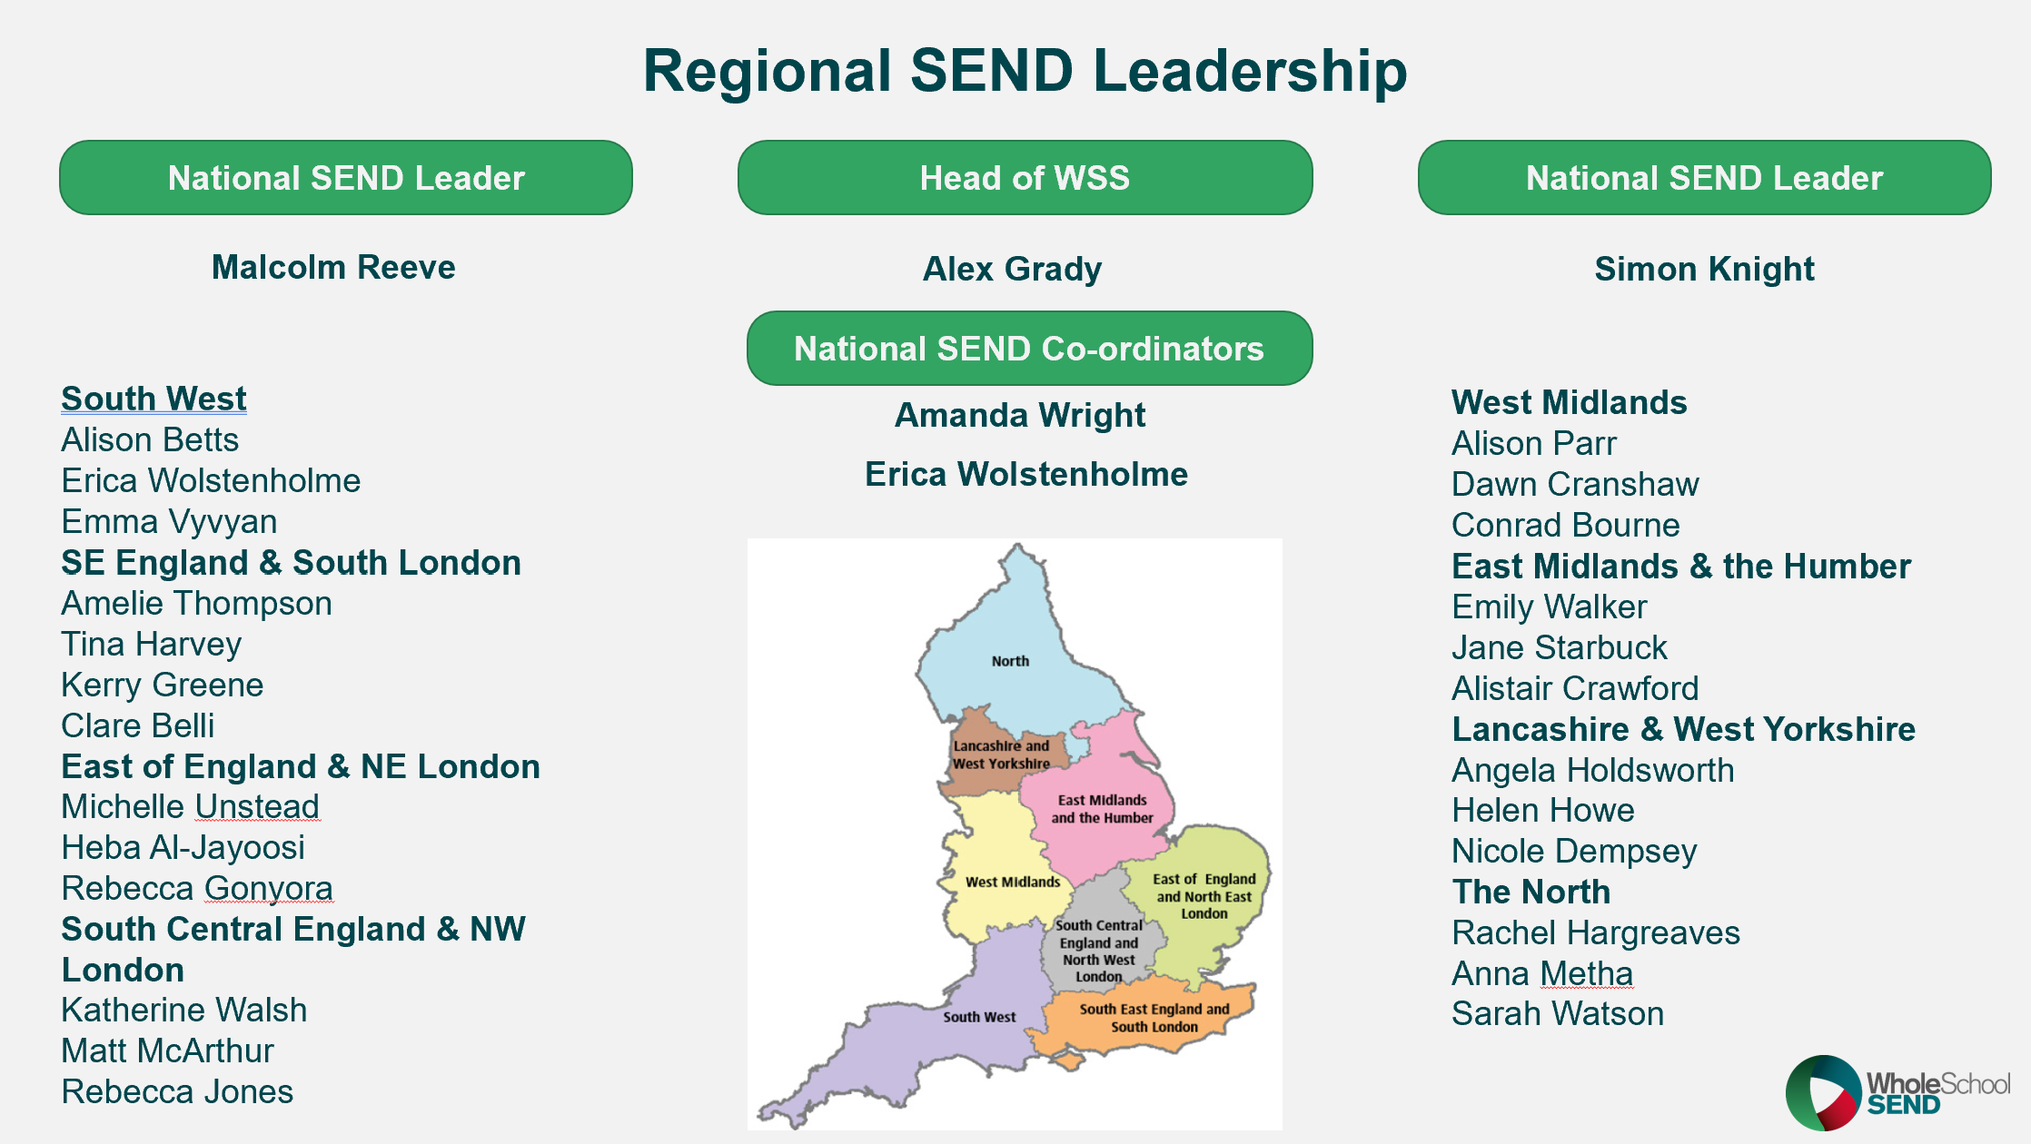

Figure 22. Overview of regional SEND teams

Implementation: Summary of activity within the strand

Each RSC region was allocated 54 days using a bespoke approach based on their knowledge of the region to engage local authorities, teaching school hubs, universities, early career and Initial Teacher Training Advisers, multi-academy trusts, schools and their staff in Whole School SEND work and activity. Typically, the Leads contact key staff to promote the Whole School SEND programme and discuss potential support. They draw on data provided by the National Coordinators on membership and engagement in their region to strategically plan their approach. Alongside local and national SEND data, this supports the Leads to better understand the needs of the local authorities and schools and to inform their discussions.

Evaluation

To understand the experiences of those involved with the Whole School SEND programme and to evaluate the progress towards achieving the aims of the strand, a range of evidence was gathered, including:
- Feedback from the WSS membership survey: this provided information on engagement with the regional teams with evidence of outcomes and impact.
- Feedback from members’ focus groups.
- A mix of face to face and virtual meetings with each of the eight regional teams, using the questions in figure 23. During the meetings the Regional Leads spoke of the activities that had the greatest impact and provided supporting evidence (see appendix 10).
- Completion of a regional network evaluation grid (see Appendix 11)
- Analysis of Leads’ timesheets

Figure 23. Regional networking review questions

What went well
Leads identified the following successes:
- Every LA in the North has now been represented through sign up( an increase of 63% in membership rate) and in webinar uptake (increase of 36% )
- Relationships and links with a number of the teaching school hubs. We have led several sessions with the hubs and seen a spike in those areas in terms of membership and being asked to further develop our work.
- Ongoing work with a MAT over a period leading to increased knowledge and understanding of SEND.
- In the summer term we set up a regional SENCO network with a SENCO information briefing. The Regional Lead delivered a session on the Ofsted inspection framework, and we provided a resource sheet for information. As a result, we saw an increase in membership across the region.
- Links with the Opportunity Areas are working well. We have been part of the specialist offer in some OAs.
- ‘Every teacher a teacher of SEND’ and ‘Every leader a leader of SEND’ is now widespread across the region. People are using the phrase both at LA and school level.
- Specific signposting and raising awareness for colleagues across the education system. After introducing WSS I am asked to present then feedback about the resources this is really positive e.g. will be used as part of ongoing CPD for staff
- We have noticed that the 'brand' of Whole School SEND is supporting engagement with the message across a range of networks - there is a recognition of the brand and the quality of training/messaging/resourcing that comes with this.

“SENCO’s, SLT, governors, trustees and Trust Central School Improvement Team are up to date with key information and documentation from DfE, Ofsted, the EEF, NASEN, to implement and further refine provision.”
Regional lead

The WSS membership survey provided further information of the levels of engagement of members with their Regional Leads and evidence of outcomes and impact. Members engaged with their Regional Leads through a range of networking opportunities: webinar attendance and virtual meetings, training through the local authority, attending courses and events such as nasen Live, newsletters and social media platforms such as Twitter. Members who had engaged with their Regional Leads showed high levels of satisfaction, 97%, with this engagement.

I have been in contact with our regional representative over a number of years in relation to circulating opportunities across our group of schools. The WSS conference a few years ago (at Roehampton) was also fantastic but the online events have the advantage of being able to watch them back and take more detailed notes along with sharing them more widely with members of staff
Member, membership survey

Outcomes

Evidence from the membership survey showed that engagement with Whole School SEND through networking is having a positive effect on outcomes in schools:

Figure 24. Outcomes achieved due to regional networking. Source: membership survey
Members reported on changes to their own practice, the practice of others and to the leadership of SEND. An increase in levels of confidence was referenced in several responses in the survey as well as being evidenced in other strands. The benefits of engagement as a regional and national knowledge exchange were also highlighted as a positive outcome. As a result, members were able to offer quality support to colleagues.
Changes to the leadership/ policy of SEND
‘By working on PfAEY we have made excellent changes to curriculum, staff training and school culture/ ethos.’
Changes to the practice of others
‘We have looked again at our identification process, particularly of MLD, and focussed on the inclusive classroom.’
Changes to my own practice
‘Increased levels of confidence as well as knowledge and understanding.’

Impact

The activities listed below, facilitated by the Regional Leads, were identified by the Leads as likely to have resulted in the greatest impact on children and young people with SEND (see Appendix 11 for further reference):
- Attendance at local network meetings (delivery of awareness raising and signposting to WSS resources and activities)
- Regional planning with stakeholders
- Sharing of information with leaders, teachers and the wider staff in schools
- Meeting with Teaching School Hub Lead
- Delivery of training / CPD to schools

The results of the membership survey highlighted the following:

Figure 25. Impacts achieved due to regional networking. Source: membership survey

Members identified the following as having the most evidence of impact from networking with their Regional Leads:

Barriers
We identified the following barriers:
- 77% of members had not engaged directly with their regional team; reasons given were that members were unsure how to contact their Leads, and lack of time.
- Whilst the CPD programme was prepared by each region it was available to all and this reduced the need to communicate with a lead within their region. Access to all for the CPD programme has increased reach nationally but has limited the need for direct regional contact and therefore members do not know their regional teams was well as they did when events were planned face to face.
- Not all regions were able to use all their networking days as high staff absence because of Covid meant that Leads sometimes had to provide cover in their schools.
- Not all regions have been able to operate at full capacity because of temporary gaps within two teams.

Key Learning
- Signpost to the resources on the website through regional network meetings. Evidence shows these are regarded as a trusted source and increasingly organisations wish to reference their engagement with Whole School SEND on their websites.
- Enhance the regional focus by improving communication channels such as regional updates in the monthly e news, which Leads could then send out through networks such as the Regional School Commissioner’s bulletins.
- Continue to develop connections with strategic leaders, as where regions have been able to make contact and are engaged with the Regional Schools’ Commissioner, LA Leads and MAT leaders network, this was helpful in disseminating information across schools.
- Engage with Teaching School Hubs, as connections have provided a good forum for networking; where a hub is engaged with WSS membership rates have increased in the location.
- Consider using the content of the CPD programme to establish new networks such as governors and use zoom accounts to facilitate meetings.
- Develop and extend networks through the model of professional development groups; many members were employed in schools which are part of a MAT or they have subsequently been appointed to outward facing roles and have shared details of WSS across the trust.
- Maintain relationships between Leads and the members of professional development groups so that the latter become ambassadors for Whole School SEND and widen the network further.
- Highlight that WSS works nationally across regions so that in organisations with a high turnover, links are maintained when staff move on.

Conclusions
The regional networking strand is one of the key priorities of the Whole School SEND contract as 40% of the Leads’ time is available for it. Over the course of the contract, Leads have raised the profile of SEND with a wide range of stakeholders who operate at a strategic level in their region: the RSC, teaching school hubs, local authorities, multi academy trusts, initial teacher training providers and opportunity area Leads as well as developing further networks for governors and SENCOs.
The programme of national virtual delivery has resulted in the reduction of face-to-face contact between the Leads and the members in each region. Where there has been any engagement with the Leads in a region, the evidence from the surveys shows that this results in positive outcomes and impact. Staff in schools value the support from Regional Leads and information on resources and training that can be accessed from Whole School SEND. Furthermore, the model has significant benefits as it facilitates information streams on local SEND needs to flow from the sector to strategic Leads both across the region and nationally, so that feedback on SEND issues can be gathered from schools and key messages shared.

The Whole School SEND member community

The WSS member community refers to the group of people who have, through their free nasen membership, signed up to receive the monthly WSS e-newsletter. Membership of nasen allows access to the WSS CPD webinars and resources on the WSS website.

Intent: Aims

This section will evaluate how being part of the WSS member community benefits the school workforce. It will focus on the outcomes and impact of the WSS e-news, the WSS website and the resources available on the website. The following overarching KPIs are used to measure effectiveness:
- Proactively engage with the WSS member community to maintain momentum and support effective delivery of wider contract priorities

- Deliver high quality services which the sector incorporates into their practice and which leads to improvements in their provision

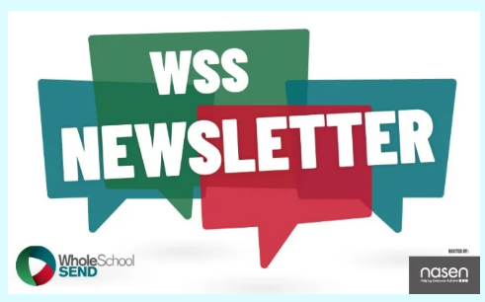
Implementation: Summary of activity
Figure 26. Image from WSS e-news

  - WSS e-news
The e-newsletter is sent to all WSS members every month. It contains the following sections:
- WSS news and updates: summaries of WSS activity
- WSS resources: updates on new and upcoming resources
- WSS events: webinars coming up in the month ahead
- nasen news: updates from nasen
- Other updates: links to resources / updates from consortium partners and other organisations relevant to the sector.
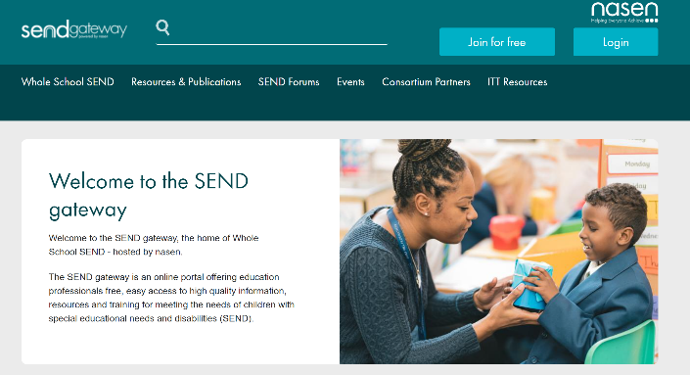
  - WSS website: SEND Gateway
The WSS website provides access to:
- Information about WSS and contact details for the regional teams
- WSS resources and publications
- SEND forums: The SLD forum, the SEND & ICT forum and the SENCO forum
- Booking pages for upcoming WSS CPD webinars
Figure 27. Screenshot of WSS website homepage
- Resources produced by WSS consortium partners
- ITT resources: online training materials to support early career teachers to develop inclusive habits.

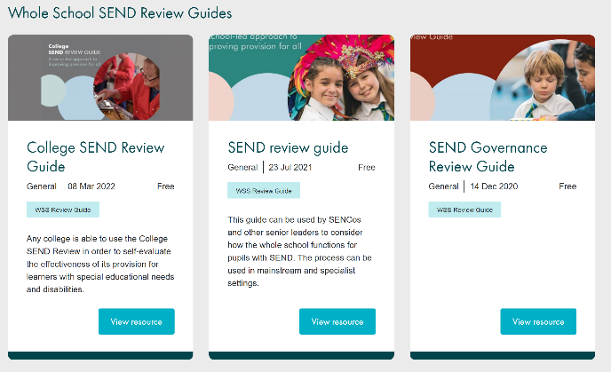
  - WSS resources
Figure 28. Example of how resources are presented on WSS website
Resources available on the website include:
- WSS individual resources and publications
- Blogs
- Condition specific videos
- Consortium partner resources
- Specialist provision area
- Teacher handbook: SEND
- What works?
- WSS Review Guides
- Recordings of past WSS CPD webinars

Evaluation

A survey was sent to all recipients of the WSS e-news to gather feedback on the benefits of being a member of the WSS member community. Data relating to CPD webinars and regional networking has been included in the sections above. Feedback regarding the WSS e-news, the website and the resources available through the website will be discussed in this section.
Two focus groups took place, following the member survey, to gather further feedback and examples of outcomes and impact.
WSS membership data is analysed to calculate a membership rate which provides a measure of membership proportionate to the number of schools in the area. This is helpful in assessing the spread and reach of WSS in order to target activity and address any ‘cold spots’ for engagement with WSS services.

What went well

Figure 29. WSS membership: engagement and feedback data. * KPI set at beginning of year 20%
  - WSS E-news
The number of people receiving the monthly WSS e-newsletter has continued to grow over the year. In March 2022, it was sent to 23,972 people, this is a growth of 69% over the year. Membership has grown steadily in all regions, with an average growth rate of 48%. The North region has seen the largest growth rate (63%). Whilst this region continues to have the fewest members, it has an above average membership rate and has seen the second largest increase in membership rate since June 2021 (see figure 30). The regional team in the North report that they have used the regional membership data to target areas with lower engagement in their networking.

Figure 30. Increase in WSS membership rate

WSS membership covers all roles within the school workforce (see Appendix 12). SENCOs make up the largest group. Members value the information and updates included in the newsletter and report that it enables them to make efficient use of their time. A SEND MAT lead described how the regular updates on developments in SEND makes her job significantly easier as she can cascade the information to the SENCOs in the trust. Responses in the member survey confirm that the e-news is a valuable resource for members.
“Good to have key info and CPD info in one place and sent to me so I can plan my time and make full use of resources”
Member, membership survey
“It gives me all the info that I need in precise, short bites and provides me with resources at hand. I always save each newsletter to refer back to”
Member, membership survey

  - WSS website
There have been over 186,000 users of the website. Feedback from the membership survey shows that 72% of respondents have used the website. The main reasons for not using the website are reported to be:
- Lack of time (63%)
- Not being aware of it (22% of people gave a reason similar to this)
- Difficulties with finding information needed (10%)

Members report they mainly use the website to access specific resources / information (60%) and to find out about and book CPD webinars (35%). Less than 1% of members use the website to go on the forums.
  - WSS resources
Of the people who have used the website, 99% of them have accessed the resources available. The Teacher Handbook: SEND is the most popular resource (77%). Other popular choices were other individual WSS resources (49%) and the SENCO induction pack (46%).

Outcomes

Data collected from the membership survey indicates that using the WSS resources is having a positive effect on outcomes in schools.

20.15% report changes to the leadership / policy for SEND.
29.75% report changes to their own practice.
37.75% report changes to the practice of others.

Figure 31. As a result of WSS membership, what outcomes have been achieved? Source: WSS membership survey

Many responses referenced using WSS resource when delivering CPD in schools and how this has resulted in changes in practice of colleagues in the setting. Several members made reference to using the resources to influence the knowledge and understanding of early career teachers.
“I have seen the knowledge of trainee teachers develop from these resources and their understanding of what inclusion means evolve over time”
Member, membership survey

Examples of changes to the leadership of SEND include:
- Reviewing identification of SEN procedures
- Changing target setting systems
- Reviewing of interventions
- Conducting SEND reviews using WSS review guides – school, MAT and Governance
- External support services changing practice to influence provision in schools for pupils with SEND.
“I have changed some of the questions that I ask at PEP meetings for all SEND pupils to ensure that transition to adulthood is actioned for all ages.”
Member, membership survey

Impact

Members were asked what the most significant impact for each of the WSS resources has been. The Teacher Handbook: SEND was considered to be the most impactful.

Figure 32. What has been the most significant impact as a result of using the WSS resources?

The most common impact reported by members was more inclusive high-quality teaching in the setting.
26.09% report a more inclusive ethos in the setting to be the most significant impact.
13.32% report earlier and more accurate identification of SEN to be the most significant impact.
31.46% report more inclusive high quality teaching to be the most significant impact.

Figure 33. As a result of WSS membership, what impact has there been?
“Teachers have more understanding of SEN approaches. Whole school APDR improved”
Member, membership survey
“As a result of WSS the ethos in classrooms has changed and following the use of the resources I am finding new teachers are more reflective ”
ITT provider, membership focus group

Barriers
We identified the following barriers:
- Members report that a lack of time is the main reason for not reading the WSS e-news.
- A significant number of members reported that they do not know what the WSS e-news is.
- Some members lack awareness about the WSS website. Others report that they find it difficult to find time to use it.
- Some members report they ‘cannot afford’ to access paid for resources – this could indicate a lack of awareness of the free nature of WSS resource.
- There is an abundance of support and resources available on the website. Some members do not have time to familiarise themselves with it all.

Key Learning
- Continue to target geographical areas with lower membership rates through regional networking
- Ensure members are aware of e-news
- Continue to work to clarify the relationship between nasen and WSS for members
- Consider how to provide support and useful resources to schools, without overwhelming. Feedback relating to the e-news is remarkably positive, there may be potential to make it more personalised to the recipient eg. setting / role / region specific. This may be a more efficient way of sharing updates / resources.
- Consider reorganising resources on the website to facilitate ease of access.
- Consider how to provide more networking opportunities through the WSS membership.
- Continue to develop the specialist section of the website

Conclusions

The WSS membership community has grown, substantially, throughout the year. This is likely to be because of the high levels of satisfaction reported by members and subsequent dissemination of materials, thus promoting further engagement. Alongside this, regional leads have been able to work strategically to target local areas with lower membership rates. Momentum within the member community has supported effective delivery of wider contract projects, for example the high rate of interest in the PD group recruitment.
The evidence gathered confirms that members of the school workforce are making changes to their own practice and that of others, because of the support and materials available through the WSS member community. Members report that, as a result of using WSS resources, improvements have been made to the provision for pupils with SEND in their settings; most significantly, they report more inclusive high quality teaching in their settings.

Conclusions and recommendations

Conclusions
From the evidence presented in this report, we conclude that Whole School SEND has continued to develop and build on previous years’ activity to embed effective SEND provision within school improvement and to equip the school workforce through high quality training and CPD to prioritise and understand their responsibilities in relation to SEND. This has been achieved by delivering high quality services which the sector incorporates into their practice, and which lead to improvements in provision in schools.
We know that, whilst lack of time can be a barrier to engagement, the Whole School SEND publications are valued by the sector as a trusted resource. This is evidenced by the high number of people accessing recordings and the number of downloads of resources such as the Teacher Handbook: SEND. Moreover, evidence indicates that engagement with one aspect of Whole School SEND often results in further engagement with other aspects of the programme. The resources not only had a positive outcome for the individual, but these individuals were also likely to disseminate the information more widely; it is reported that this led to changes in the practice of others.
Furthermore, the projects that were delivered over time such as the professional development groups and the local authority strand were greatly appreciated by the sector and resulted in positive outcomes and impact. Whilst the section of the workforce most likely to engage in activities were SENCOs at all stages of their careers (including multi academy trust SEND leaders), where headteachers and senior leaders were also engaged, the project was likely to be more impactful for children and young people with SEND in schools.

Continuing impact of COVID-19
The impact of Covid-19 in the contract year 2019/20 was significant, and so the work streams as outlined in the contract for 2020/21 prepared for further restrictions by ensuring that delivery was digital by default. Webinars were transmitted live, mostly at the end of the school day, but were also recorded. However, despite this, it was evident that schools were challenged with managing operational demands, especially between the months of December to February. Attendees at live webinars would often be called away and more of the PD group professional conversations had to be re-arranged as members had to cover for staff absence.

Recommendations

Communication/ to increase the membership
- Strengthen lines of communication between Whole School SEND and the membership community to ensure a regionally bespoke offer whilst capturing the voice of the sector to feed into Whole School SEND work, by providing regional information in the monthly newsletter.
- Consider how to develop and sustain existing networks, by using some of the Regional Leads networking time to provide updates on WSS content and publications.
- Maintain and increase engagement by ensuring that all activity responds to the needs of the workforce: topics of particular interest are currently the inclusive classroom, social and emotional well being, leadership of SEND and early identification and intervention.
- Consider how engagement could be broadened to the wider workforce (including teachers and support staff) without losing the engagement of SENCOs by using the information from national and regional leaders to respond to the needs of the workforce.
- Increase the engagement of leaders by identifying activity that responds to their needs as the evidence gathered suggests that including CEOs, the executive leadership team, headteachers and governors has a positive effect on the outcomes and impact of projects.

CPD
- Develop a CPD offer that the workforce can access at the point of need and work through as required whilst maintaining opportunities for interaction and networking with colleagues.
- Ensure that the CPD offer provides models from schools of examples of the application of pedagogical theory in practice.

Professional Development Groups
- Develop projects, such as the professional development group model, that take place over time and ideally combine both group sessions and 1:1 professional conversations, which provide a deeper understanding of SEND.
- Use the learning from the projects to provide models of good practice to disseminate to the wider workforce.

Appendices

Appendix 1 – WSS membership survey
Total number of survey respondents: 603
The WSS membership survey was developed to gather evidence of feedback, outcomes and impact from a range of WSS services. Questions were arranged into the following sections:
- WSS e-newsletter
- SEND Gateway and WSS resources
- WSS CPD webinars
- WSS regional SEND team networking
Each section included the same standard questions to elicit evidence of outcomes and impact in schools as a result of accessing WSS services:
‘As a result of accessing < WSS resources / CPD webinars / the regional SEND team>, what outcomes have there been?’
‘As a result of the outcomes referred to above, what impact has there been?’
The results of these questions are represented in figures 2 and 3. The chart below shows the number of responses for each section of the survey. As the resources question refers to 11 separate WSS resources, responses have been accumulated for figures 2 and 3.

Survey section | Responses
WSS e-newsletter | 465
SEND Gateway and WSS resources | 224
WSS CPD webinars | 154
WSS regional SEND team | 68

Appendix 2 – Governance and oversight
GOVERNANCE AND OVERSIGHT
The Consortium Impact Steering Group met four times over the year to support dissemination of WSS outputs and strategy for maximising the impact of the work. During the year, the Youth Steering Group of 16-25 year olds also met four time to continue to support the work of this group, ensuring that learner voice informs the work of WSS – the chair of this group feeds back to the Consortium Steering Group.
nasen has a range of internal governance mechanisms: The Contract Management and Delivery Assurance committee of the nasen trustees oversees the Whole School SEND contract and reports to the full Board of Trustees each quarter. The WSS programmes team hold weekly project management review calls and nasen’s Executive Leadership Team hold monthly project governance meetings to ensure project delivery is on track. nasen and WSS sub-contractors report to the Department for Education using the quarterly reporting cycle, and WSS hold at least weekly ‘keeping in touch’ meetings with the contract manager at the DfE.
Appendix 3 – Regional webinar attendance

Region | Live | Recording | Events
South East England and South London (SESLON) | 656 | 894 | 7
West Midlands (WM) | 461 | 672 | 7
South Central England and North West London (SCNWLON) | 550 | 740 | 7
East of England and North East London (ENELON) | 497 | 712 | 7
South West England (SW) | 334 | 513 | 7
East Midlands, South Yorkshire and the Humber (EMSYH) | 380 | 518 | 7
Lancashire and West Yorkshire (LWY) | 438 | 573 | 7
North of England (NORTH) | 280 | 404 | 7

Appendix 4 – PD groups selection criteria

- Each region was assigned a theme based on the first or second more popular response in that region (assuming both were ranked at least 6 out of 8, or 75%). Second choices were assigned to give distribution of themes across the regions.
- Applicants were divided into regions, based on the locations of their schools.
- Applicants who had selected the assigned regional theme as their first choice were prioritised (to maximise engagement and interest from group members).
- Applicants from leadership roles were prioritised (as these applicants may have more opportunity to implement change and impact practice at a whole-school level).
- Applicants from Special and AP/PRU settings were prioritised (to ensure representation from all settings in each group).
- Applicants from Secondary were prioritised (to ensure representation from all phases in each group).
- Applicants from LAs with Written Statements of Action were prioritised (as need is likely to be stronger in these areas).
- Applicants from schools for which Ofsted have previously issued necessary improvements related to SEND were prioritised (to attempt to have maximum impact on outcomes and provision directly for children and young people)

Section A – Background Information
Local Area |  | Region
Inspection Date |  | Inspection Outcome
Revisit Date |  | Revisit Outcome
Current Status | NYI / no WSoA / WSoA / APP | WSoA / APP themes (if applicable)
CCG
SEND Adviser |  | LA SEND Contact
NHSE Adviser |  | DfE Case Lead
Key area(s) for which support is needed and does this align with areas of weakness in the WSoA / APP?
Has this LA previously received any Targeted Delivery Support? If so, please provide more details
SEND Adviser comments
Proposed Delivery Support Partner |  |  | CDC MAW / CDC SC / NDTi / WSS
Individual Targeted Delivery Support Request Form
Appendix 5 - Individual targeted delivery support request form

Section B – Targeted Support Plan
Summary
Proposed start date
Estimated completion date
Days (or cost if WSS) for preparation
Days (or cost if WSS) for delivery
Days (or cost if WSS) for follow-up
Total days (or costs if WSS)
Description of the proposed support i.e., what will be provided? Include further information on preparation, delivery, and follow-up activities
Description of the issue(s) that the proposed support will address
*For areas subject to a WSoA / APP, please provide information on how the support is intended to help address areas of significant weakness
Description of the impact the support will make i.e., an outline of the impact the proposed work is expected to achieve and details of how the impact will be evidence

Section C – Agreement
Have all relevant parties agreed on the key area(s) for which support is needed?
Have all relevant parties agreed on proposed Targeted Support Plan in Section B?
Confirmation of delivery number (DBOT only)
Date
Appendix 6 – 2a LA status review (January 2022)
Local Authority | Project Status (end of Q3)
Bristol, Dudley and Central Beds | Full support package delivered and completed
Cumbria | Full support package delivered and completed
Luton | Full support package delivered and completed
Medway | Full support package delivered and completed
Oldham | Full support package delivered and completed
Redcar and Cleveland | Full support package delivered and completed
Sefton | Full support package delivered and completed
Staffordshire | Full support package delivered and completed
Bournemouth, Christchurch and Poole | TDS request from is currently being reviewed by the SEND Adviser and will be submitted to the Moderation Group Panel w/c 10th January.
Buckinghamshire | Support package agreed by DfE Moderation Group Panel. Planning meetings have taken place to agree dates and times of training sessions.
Leicester City | Support package agreed by DfE Moderation Group Panel. Planning meetings have taken place to agree dates and times of training sessions.
Newcastle Upon-Tyne | Support package agreed by DfE Moderation Group Panel. Planning meetings have taken place to agree dates and times of training sessions.
North Somerset | Support package agreed by DfE Moderation Group Panel. Planning meetings have taken place to agree dates and times of training sessions.
Sunderland | Support package agreed by DfE Moderation Group Panel. Planning meetings have taken place to agree dates and times of training sessions.
Thurrock | Support package agreed by DfE Moderation Group Panel. Planning meetings have taken place to agree dates and times of training sessions.

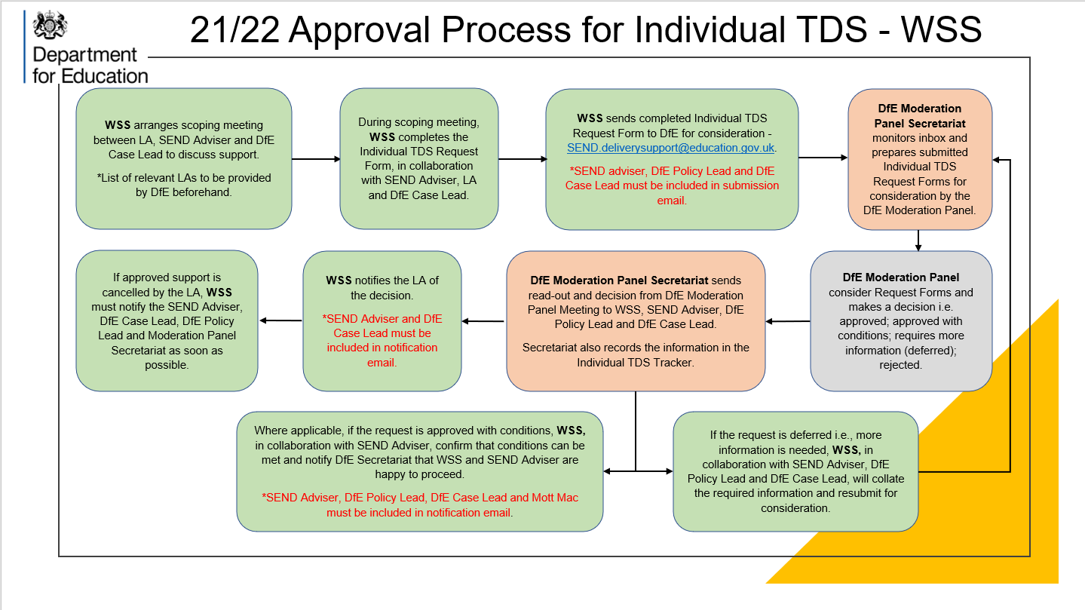
Appendix 7– Targeted Delivery Support process

Appendix 8 – Anonymised primary SEND in a nutshell
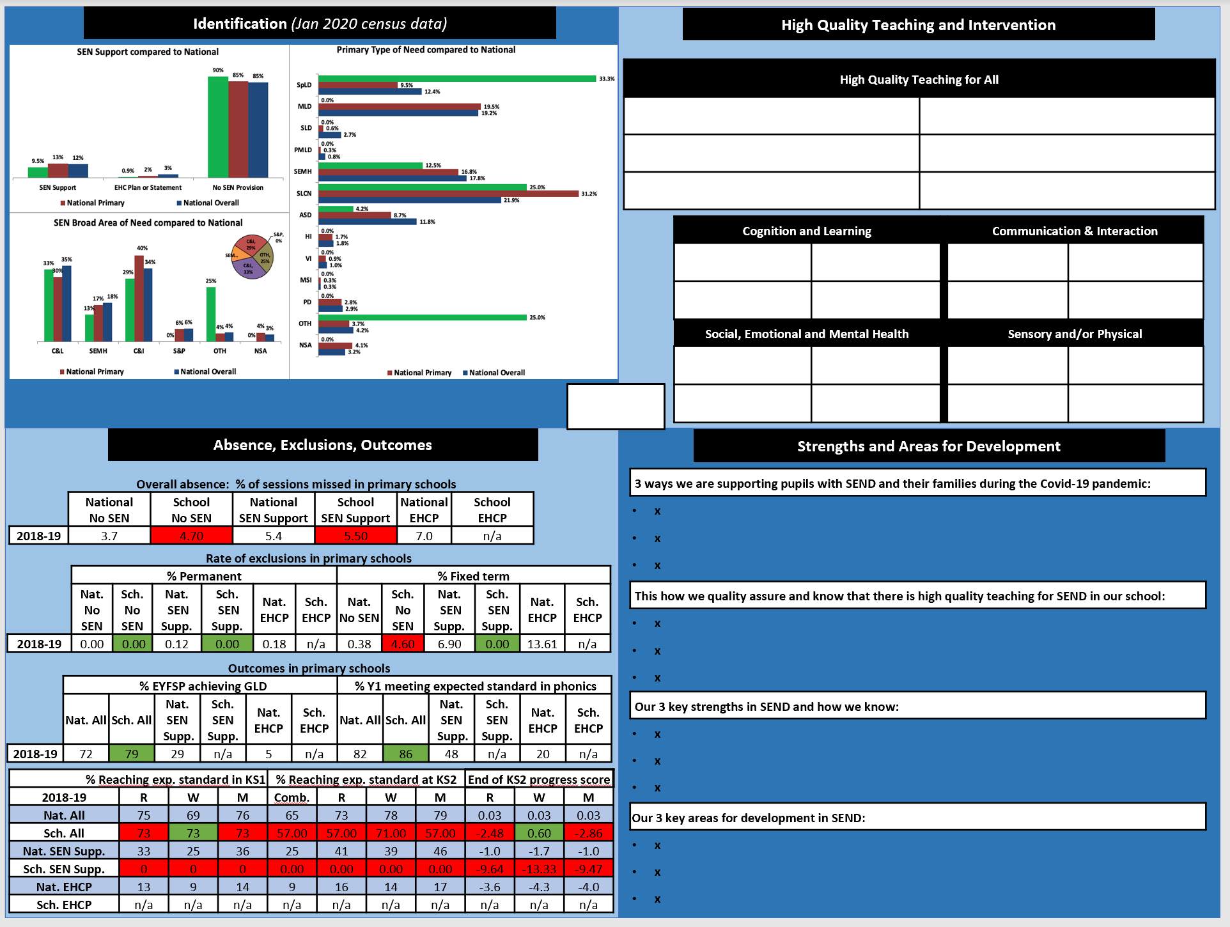

Appendix 9 – LA case study
Whole School SEND and local authorities working together: a case study

Local authority context:
This smaller than average local authority, situated in the South East London and South England region, was subject to a written statement of action following their local area Ofsted SEND inspection and subsequent revisit. Ofsted identified that mainstream schools across the authority had an inconsistent commitment to inclusion and to responding to the SEND reforms. Some schools were confident in meeting a range of special educational needs and made appropriate requests for education, health and care needs assessments, whilst others seemed to believe that if a child or young person had special needs then they should attend a specialist setting. The number of children and young people with education, health and care plans being educated in mainstream schools was lower than in most other areas of the country.

Intent of WSS project:
The local authority wanted to use the support of Whole School SEND to open up discussion with school leaders about their responsibilities to children and young people with SEND. It was important to the LA SEND team that the package of support encouraged headteachers to ‘buy-in’ to the intentions of the training and not to feel that this was a directive handed down to them. By encouraging reflection on their own policy and practice, change in schools would be sustainable. It was agreed by Whole School SEND and the LA that focussing on SEND identification and progress data would encourage this debate. The aim was for SENCOs, head teachers and governors to start asking questions about their own data - ‘what does my school’s data look like and why?’. In particular, the LA wanted the schools who believed that pupils with EHC plans should attend special schools to realise that this is not the picture across the country. Using the data from Special educational needs in England: January 2020would be a factual and unobtrusive approach. The LA were very clear that they wanted school leaders to experience a ‘gentle realisation’ that they were not as inclusive as they thought they were, and they wanted to give SENCOs the tools to enable them to work more strategically in their settings.
The ‘SEND in a nutshell’ resource, developed by Malcolm Reeve, WSS national lead, was the perfect tool for schools to present and analyse their data. This one-page presentation of a school’s SEND context and priorities for improvement gives a succinct overview of the strategic leadership of SEND. In order to promote further ‘buy-in’ from schools, nutshells were completed for all schools involved in the project.

Implementation:
The package was delivered over two phases. The first, whilst being aimed at secondary schools, was open to all schools across the area. Training sessions were also attended by LA staff, educational psychologists and advisory teachers and included:
- Briefing session to Headteachers
- Every Leader a Leader of SEND
- SEND in a Nutshell
- High Quality Teaching and Learning strategies
- Every Governor a Governor of SEND
All training was delivered virtually. The sessions were interactive, the chat was well used and staff at the local authority were receiving emails during the sessions to seek further clarification or support around individual school issues. Already, schools were reaching out to discuss issues relating to SEND; exactly what the LA had hoped for.
Feedback proved the training was well received; schools who had not taken up the offer of training were phoning the local authority to ask how they could get access to the materials. School leaders were starting to discuss the issues raised with colleagues in other schools.
Due to the demand from local schools, it was agreed to run a further training package to revisit the themes of the first package and to include a session on using the WSS SEND Review Guide for schools to be able to evaluate their own provision. Schools were very keen to get their own ‘SEND in a nutshell’ document and not to be ‘left out’.
Several schools who had attended the first sessions asked if they could send colleagues to the second phase of training. This included headteachers, who had attended first time, sending SENCOs to the second round and SENCOs, from the first group, sending their headteachers to the second set of training. There were some schools who had not accessed the training first time round, who were known by the LA to need further support with developing inclusive practice. LA SEND leaders made personal phone calls to these schools to invite them to the second package. This targeted approach secured engagement from some schools while others declined the offer. These schools felt that they accessed this support from their trust.
After the first phase of WSS training, LA SEND Leads presented the findings to the SEND partnership board to share the work and further embed the consistent message coming from the local authority.
Away from the training sessions, the local authority used the resources and key messages to drive change in schools and across multi-academy trusts. Through making CEOs aware of the information that has been given to head teachers and SENCOs, the LA are encouraging settings to engage in strategic, data-driven conversations. Threaded through the training was the message that the information would also support schools to prepare for Ofsted, which proved to be a useful hook to initiate engagement.

Outcomes and Impact:
School leaders are talking about and taking more responsibility for their pupils with SEND. The package of support from Whole School SEND has started the debate the local authority had hoped for. By analysing their own SEND data and comparing with local and national figures, school leaders have started to ask themselves questions about the identification trends in their own settings, resulting in more open and transparent conversations with the LA SEND team. Head teachers are now contacting the LA SEND team seeking advice on how to increase staff confidence to meet certain areas of need. This has resulted in the Educational Psychology service developing training to fill these gaps.
The LA use the identification data to engage in solution focussed conversations with those schools, which are reluctant to accept a pupil with an EHCP, especially when the school has a below average percentage of EHCPs. When schools are feeling overwhelmed with the number of pupils with SEND in their setting, the LA can now engage in data-driven conversations to urge further reflection around how the school can meet the needs of the children and young people in their community. This is further supported by comparing data from other schools in the area. Schools can see how their SEND population compares with other local schools, which often has more relevance than a national average.
Schools in the local authority are becoming more confident in providing a whole school approach which meets the needs of children with SEND. One headteacher described how the SEND in a nutshell tool has forced them to review how SEN is identified within their school. After seeing how their data compares with other schools, they began to reflect why their data looked different. Previously, a large proportion of the SEND population at that school had their needs recorded as ‘other’. After participating with the LA WSS project, this has reduced and needs are being more accurately identified.
“The SEND in a nutshell has really highlighted to us how we need to look carefully at the reasons why children are put on the SEN register.” Head teacher

Key learning
- The WSS package complemented the LA SEND strategy. Work was already in place to develop a document to support schools’ understanding of what should be universally available in mainstream settings. The facts and figures provided through the SEND in a nutshell document added further gravitas to this work. Planning ensured that the support from WSS was complementary to that being offered by the LA.
- The WSS training and associated support from the LA was delivered through a coaching approach. Schools were encouraged to ask questions of themselves, rather than being told what they had to do. This has helped build relationships between the LA SEND team and schools.
- A range of LA staff attended the training alongside the school workforce. This ensured that the key principles and resources of the project can be revisited and strengthened during ongoing school visits.
- Engagement and ‘buy-in’ from school leaders was ensured by providing a valuable data analysis resource which they could take away and begin to use in their settings. The SEND in a nutshell document was considered a ‘gift’ by school leaders. Linking this tool with statutory responsibilities as described in the SEND Code of Practice and descriptors from the Ofsted framework reinforced the notion that this was something that schools needed to engage with.
- The local authority viewed the WSS project as part of their journey of improvement. It was never considered as a silver bullet to ‘fix’ inclusion across the group of schools, but rather part of a well planned and considered approach to opening up the debate and encouraging schools to reflect on their own approach. The journey continues beyond the WSS training sessions and this sustainability was planned in the initial stages.

Ensuring sustainability
In order to maintain the appetite for change from schools and sustain the drive for improving provision for children and young people with SEND across the local area, a model of peer review for SEND is being planned. Primary schools are grouped in clusters and peer reviews will be conducted within these groups. The findings from these reviews can be used by the schools to share expertise and to consider the sharing of traded services across the cluster where appropriate.
The LA SEND lead now has a regular SEND slot at the secondary heads network. This will be used to revisit the key messages of the project and stimulate continued discussion around SEND data across the authority and in comparison with national figures.

By working in conjunction with WSS to supplement the developments already in place, the LA have fostered a more inclusive approach in mainstream schools. School leaders are more engaged with the SEND agenda and local data indicates that mainstream schools in the local area are more inclusive with a higher percentage of children with an EHCP attending a mainstream setting, fewer inappropriate EHC assessment requests being submitted and fewer exclusions. During the autumn term 2021, the local authority received notification from the DFE that they will no longer be subject to formal monitoring of the WSOA having made clear and sustained progress against the key areas of focus.

Appendix 10 – Example completed regional teams review
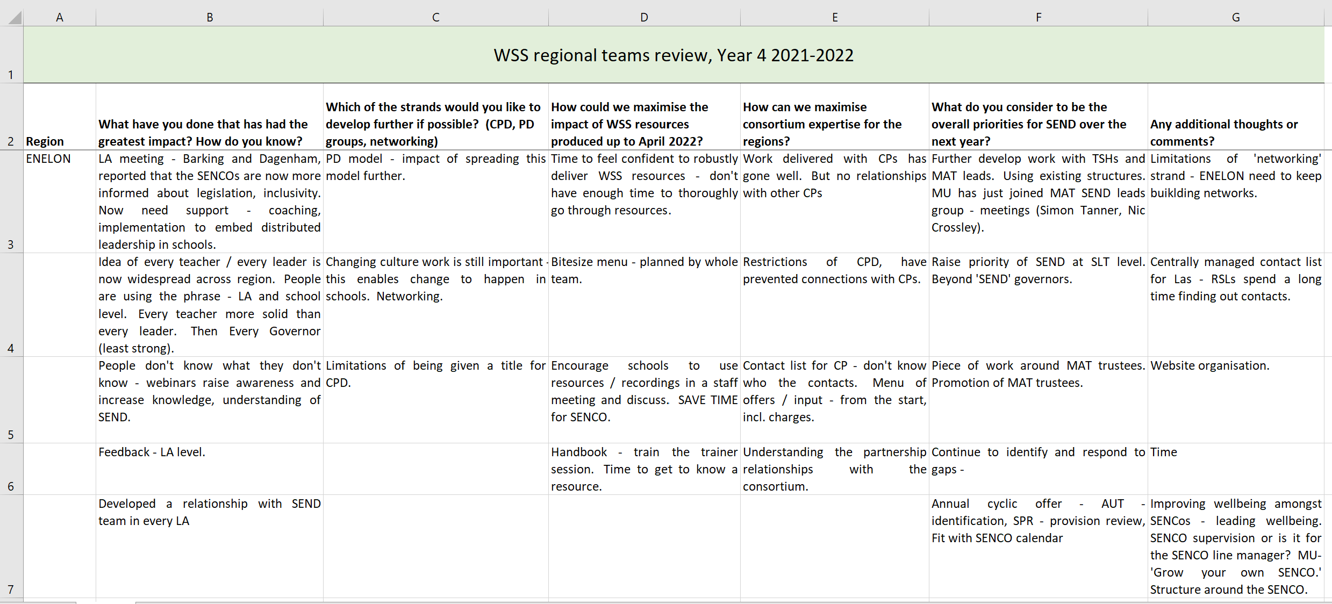
Appendix 11 – Regional networking evaluation grid

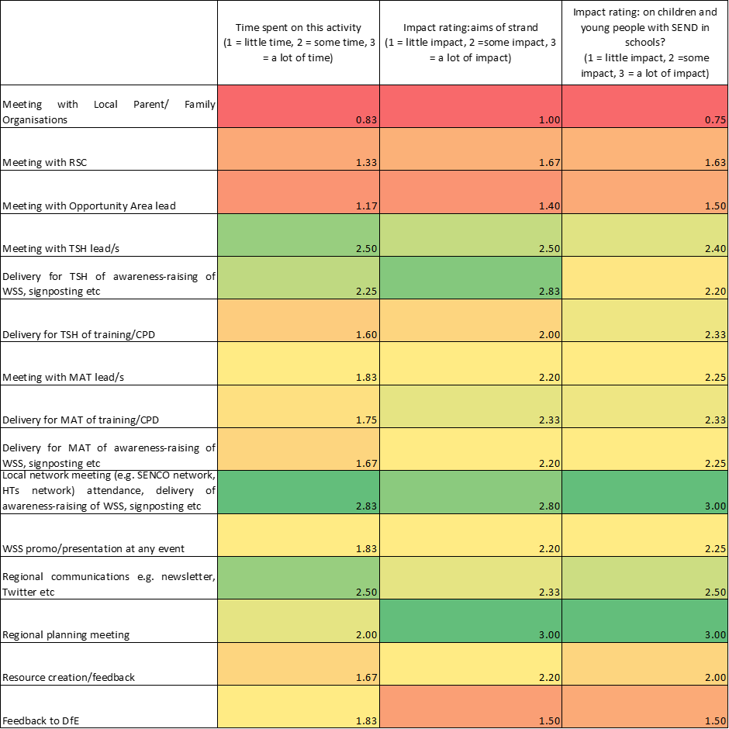
WSS membership
Role | Number | % of total
SENCO | 6516 | 34.44%
Teacher | 2275 | 12.03%
Other | 1497 | 7.91%
Teaching Assistant | 976 | 5.16%
Head Teacher | 887 | 4.69%
Early Years Practitioner | 855 | 4.52%
Student | 758 | 4.01%
Deputy Head Teacher | 746 | 3.94%
Assistant Head Teacher | 734 | 3.88%
Inclusion Manager/Leader | 658 | 3.48%
Senior Leader | 541 | 2.86%
Consultant | 512 | 2.71%
A parent/carer | 499 | 2.64%
Support staff | 477 | 2.52%
Governor | 396 | 2.09%
Newly Qualified Teacher | 255 | 1.35%
Tutor | 168 | 0.89%
Education psychologist | 160 | 0.85%
Young person | 8 | 0.04%
Grand Total | 18918
Appendix 12 – WSS membership: workforce roles

Thanks

We would like to thank everyone who completed surveys to provide data to complete this evaluation. Thanks, also, to the colleagues below who attended focus groups or 1:1 interviews:

Amanda Manlove, SENCO, Staffordshire
Amy Carter, SENCO, Staffordshire
Anna Clarke, assistant head teacher, North Yorkshire
Clare Barclay, SENCO, specialist teacher, Southwark
Claire Ostle, SENCO, Cumbria
Dawn Mcfall, SENCO, Sefton
Geraldine O’Grady, tutor, Tower Hamlets
Joseph Carroll, SENCO, Knowsley
Lucie Thornthwaite, SENCO, Cumbria
Lorraine Chester, inclusion consultant, Sefton
Margaret Relf, SENCO, Staffordshire
Natalie Meakin, SENCO, Staffordshire
Rachel Bagshaw, SENCO, Staffordshire
Catharine Forster, headteacher, Staffordshire
Grace Fairhill, assistant headteacher and SENCO, Staffordshire
Margaret Relf, SENCO, Staffordshire
Samantha Crawforth, headteacher, Staffordshire
Stephanie Jarvis, headteacher, Medway
Becky Nicholson, SENCO, Staffordshire
John Hackett, assistant headteacher, Staffordshire
Carol Ginn, SENCO, Sefton
Sarah Rogers, Staffordshire
Sebastien Crossley, MAT SEND lead, Somerset
Amanda Hicks, parent and Governor, Bristol
Patricia Barrett, inclusion lead, West Sussex
Rachael Bowman, MAT director of SEND, South Tyneside
Rebecca Green, virtual school officer, Wiltshire
Rebecca Harris, senior leader, Staffordshire
Wendy Simpson, SENCO, Northamptonshire

SEN is referenced as attainment and exclusion rates are reported for pupils with special educational needs but not for pupils with disabilities.
DfE TDS Moderation Panel consists of a range of DfE representatives from across SEND Division (see appendix 7).
Evaluating Professional Development (2000) – Thomas Guskey Sage Publications LTD USA
Teachers’ Standards (2011) Teachers’ Standards guidance (publishing.service.gov.uk)
EEF Remote Professional Development Rapid Evidence Assessment (2020) Remote_Learning_Rapid_Evidence_Assessment.pdf (educationendowmentfoundation.org.uk)

