Join our Early Years SEND Discussions on the SENCO Forum by following these 7 easy steps:
- Go to www.thesendforums.org.uk
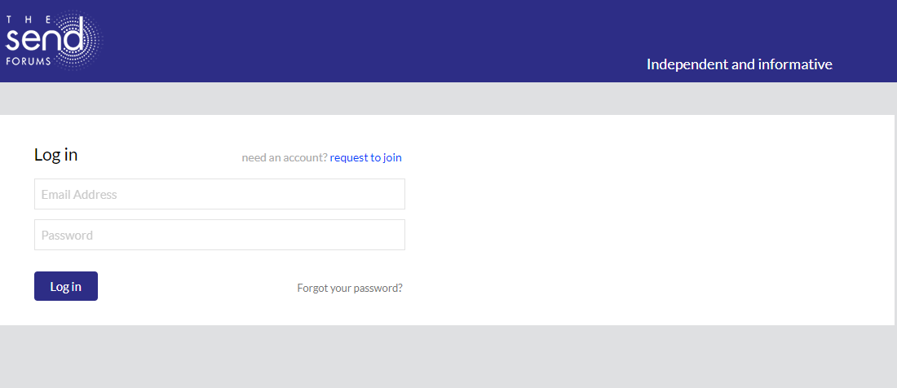

- Click request to join, complete your name, email address and a password and tick the privacy notice
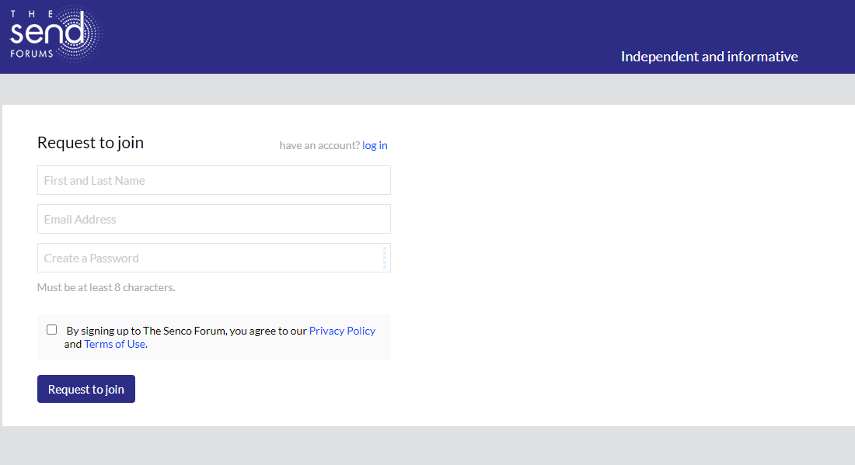

- Click request to join and you will be sent an email
- Click the link on the email and enter your username and password
- Agree to the terms of use and click continue
- Wait for an approval to be sent
- Go to www.thesendforums.org.uk and scroll down and click on Early Years

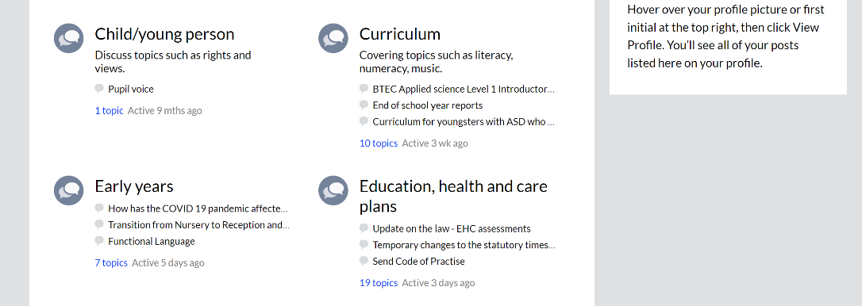

Don’t forget to update your profile:
- Once you’ve signed in, hover over your name/profile picture at the top right, then click Edit Profile.
- You can edit your name, add a tagline and other profile information. Please do let us know here that you’re an Early Years SENCO. If you include information about your role, it will help other members connect.
- You can even add a profile photo: drag and drop your image onto the page and it will automatically upload.
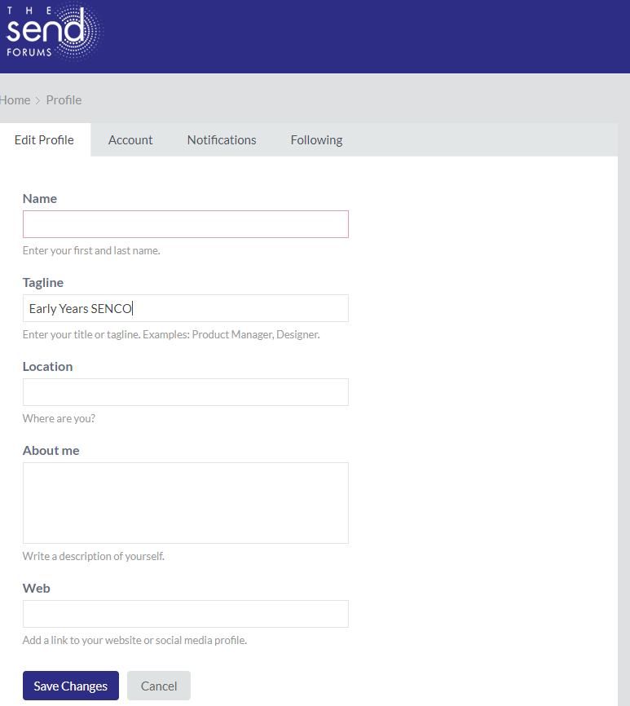

Topics currently being discussed on the SENCO Forum for Early Years SENCOs:
- Transition from Nursery to Reception and Reception to Year 1
- How has the Covid19 pandemic affected the early identification of SEN in your setting?

Topics coming soon!
- What effects has COVID19 had on co-production in Early Years settings? (5th August)
- How can we build resilience in Early Years settings in the light of COVID19? (19th August)
- What effect has COVID19 had on children with Speech, Language and Communication needs? What can we do to support these children? (1st September)

Why not join us and share your ideas and views with other Early Years SENCOs from across the country?
